HOME
ARCHITECTS ®
MAGAZINE

© Copyright 2013 Home Architect, PLLC, All Rights Reserved Worldwide
An online e-magazine affiliated with the HOME ARCHITECTS® website.
Editor: Rand Soellner, ArCH/NCARB/LHI.
HOME ARCHITECTS ®
1 . 828 . 269 . 9046
E-mail: Rand@HomeArchitects.com
Website: www.HomeArchitects.com
This issue electronically first published on 4/3/2013, from the United States of America.

Issue 12, April 2013

Hello Clients, prospective Clients & other people interested in home architecture.

You will find a brief summary about each online article, followed by a hotlink to that article. We usually will have about 3 to 6 online articles a month, contained within the latest e-magazine issue.

Just click on the links (you may have to press your control key, then click the link) to be taken to those pages on your Internet browser. If you ever lose this e-magazine, just reopen the e-mail that contains it, or send us a request and we will promptly send you another. You may save it to your hard drive, if you wish.

If you ever think of an idea for a future story, let us know! We routinely create custom articles to answer the questions of our subscribers.

You are welcome to contact us if you have any questions (about your project or our articles): 1-828-269-9046 or Rand@HomeArchitects.com .
We hope to be your architect on your next project.

You are encouraged to forward this e-magazine along to other people.
Thank you for your interest.

Top 5 House Design Features in Spring 2013

2013 is an interesting year so far. The stock market is trending higher than it has been since the Bust back in 2008. Home sales are starting to increase and inventory of distressed housing from the Boom is being gobbled up. So what does this mean for house design features for 2013?…

Click below to see the article:
http://www.homearchitects.com/top-5-house-design-features-in-spring-2013

Toilet Tank Fill Line Fix

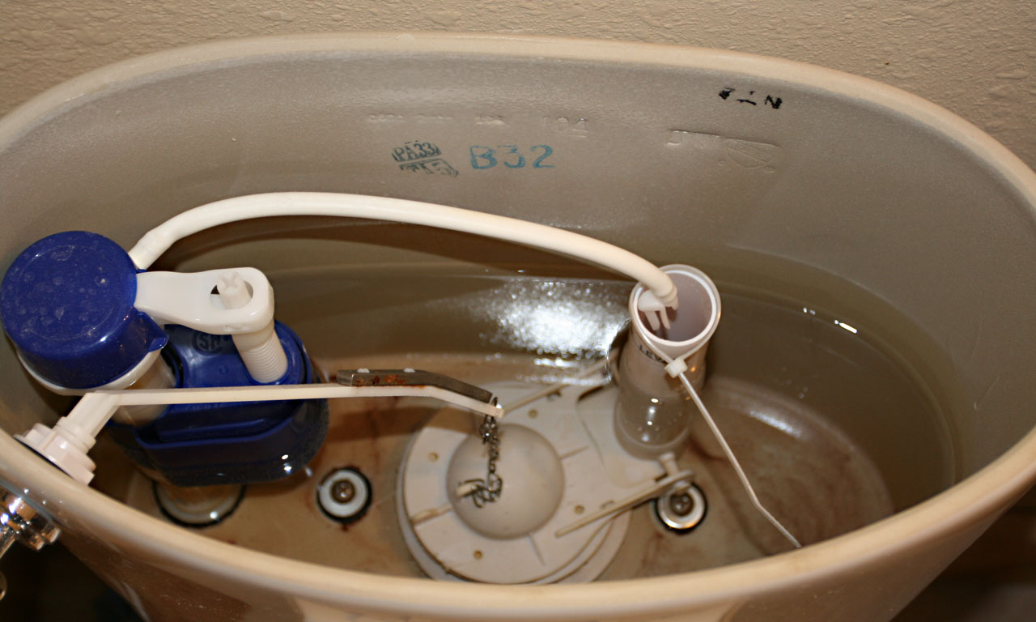

Every once in a while the folks at this architectural firm like to share some nitty-gritty knowledge with people who have interests in maintaining their house. Once such common needed repair is the pesky water fill line that keeps popping off the fill pipe inside the toilet tank. Read on to find out how…

Click below to see the article:
http://www.homearchitects.com/toilet-tank-fill-line-fix

Social Community Design Can Fix Government

How can this be? The design of how our houses are grouped, laid out and arranged with respect to adjacent residences can fix our broken government? Sounds impossible. What does one have to do with the other? Read on to find out…

Click below to see the article:
http://www.homearchitects.com/social-community-design-can-fix-government

Residential Community Water Maintenance
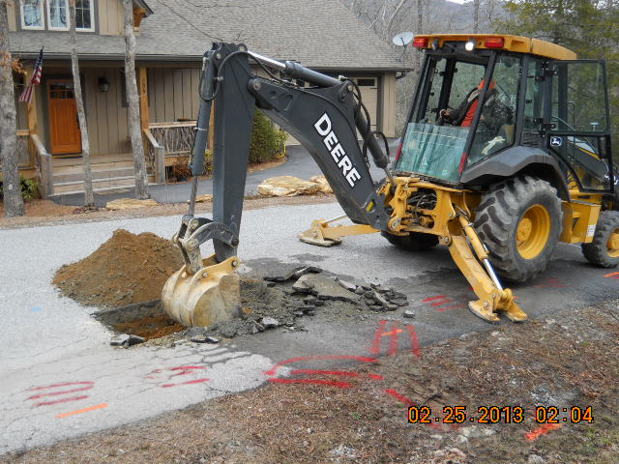

Well, no one said this blog doesn’t get into detailed technical issues from time to time. And here’s one: how your residential community water provider maintains your potable drinking water supply. If you have a well, you can probably ignore; but then again, maybe not. Read on to find out…

Click below to see the article:
http://www.homearchitects.com/residential-community-water-maintenance

End of this edition.

© Copyright 2013 Home Architect, PLLC, All Rights Reserved Worldwide
HOME ARCHITECTS ®
1 . 828 . 269 . 9046
Rand@HomeArchitects.com
www.HomeArchitects.com

Anyone is hereby licensed to forward this e-magazine to anyone else, making no changes.

