HOME
ARCHITECTS ®
MAGAZINE

© Copyright 2013 Home Architect, PLLC, All Rights Reserved Worldwide
An online e-magazine affiliated with the HOME ARCHITECTS® website.
Editor: Rand Soellner, ArCH/NCARB/LHI.
HOME ARCHITECTS ®
1 . 828 . 269 . 9046
E-mail: Rand@HomeArchitects.com
Website: www.HomeArchitects.com
This issue electronically first published on 6/8/2013, from the United States of America.

Issue 14, June 2013

Hello Clients, prospective Clients & other people interested in home architecture.

You will find a brief summary about each online article, followed by a hotlink to that article. We usually will have about 3 to 6 online articles a month, contained within the latest e-magazine issue.

Click on the links (you may have to press your control key, then click the link) to be taken to those pages on your Internet browser. If you ever lose this e-magazine, just reopen the e-mail that contains it, or send us a request and we will promptly send you another. You may save it to your hard drive, if you wish.

If you think of an idea for a future story, let us know! We routinely create custom articles to answer questions of our subscribers.

You are welcome to contact us if you have any questions (about your project or our articles): 1-828-269-9046 or Rand@HomeArchitects.com .
We look forward to being your architect on your next project.

You are encouraged to forward this e-magazine along to other people.
Thank you for your interest.

Fewer Repairs, Less Maintenance

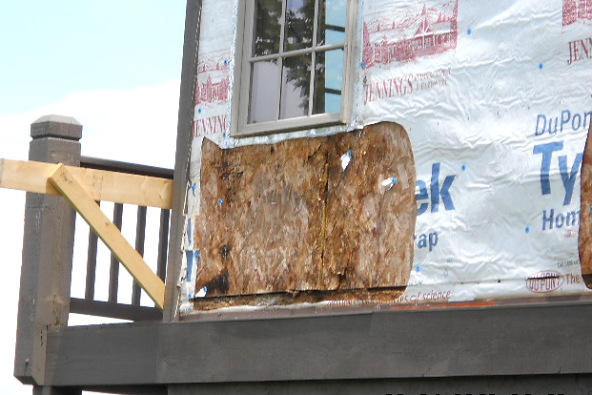

This is part of the “Value of an Architect” series. This one is: Fewer Repairs; Less Maintenance. An architecturally designed house can require fewer repairs and less maintenance. Read the article to find out more…

Click below to see the article:
http://www.homearchitects.com/fewer-repairs-less-maintenance

Architectural Design Process

Designing a house is an architectural process. Especially doing it right, to custom suit your needs. Read on to find out how…

Click below to see the article:
http://www.homearchitects.com/architectural-design-process

Why You Want an Architect

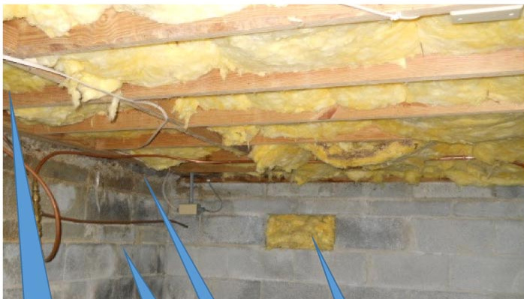

You need an Architect to DESIGN and to ADMINISTER the Construction of your new house. Why? Read on to find out…

Click below to see the article:
http://www.homearchitects.com/why-you-want-an-architect

End of this edition.

© Copyright 2013 Home Architect, PLLC, All Rights Reserved Worldwide
HOME ARCHITECTS ®
1 . 828 . 269 . 9046
Rand@HomeArchitects.com
www.HomeArchitects.com

Anyone is hereby licensed to forward this e-magazine to anyone else, making no changes.

