HOME
ARCHITECTS ®
MAGAZINE

© Copyright 2013 Home Architect, PLLC, All Rights Reserved Worldwide
An online e-magazine affiliated with the HOME ARCHITECTS® website.
Editor: Rand Soellner, ArCH/NCARB/LHI.
HOME ARCHITECTS ®
1 . 828 . 269 . 9046
E-mail: Rand@HomeArchitects.com
Website: www.HomeArchitects.com
This issue electronically first published on 8/1/2013, from the United States of America.

Issue 16, August 2013

Hello Clients, prospective Clients & other people interested in home architecture.

You will find a brief summary about each online article, followed by a hotlink to that article. We usually will have about 3 to 6 online articles a month, contained within the latest e-magazine issue.

Click on the links (you may have to press your control key, then click the link) to be taken to those pages on your Internet browser. If you ever lose this e-magazine, just reopen the e-mail that contains it, or send us a request and we will promptly send you another. You may save it to your hard drive, if you wish.

If you think of an idea for a future story, let us know! We routinely create custom articles to answer questions of our subscribers.

You are welcome to contact us if you have any questions (about your project or our articles): 1-828-269-9046 or Rand@HomeArchitects.com .
We look forward to being your architect on your next project.

You are encouraged to forward this e-magazine along to other people.
Thank you for your interest.

Index for this issue:
- Programming Your New House.
- Comprehensive Rainwater Management Plan (CRiMP)
- Toilet Fixer Person: new superhero
- Encapsulated Crawlspace

Programming Your New House

Programming is the first activity that any responsible licensed Architect will conduct for any type of project, commercial or residential. During Programming, the Architect first and foremost: listens to the Client tell him or her what they want. Read the article to discover more…

Click below to see the article:
http://www.homearchitects.com/programming-your-new-house

Comprehensive Rainwater Management Plan (CRiMP)

A Comprehensive Rainwater Management Plan ™, also known as a “CRiMP ™” is a set of documents created by a licensed Architect that details how to manage and redirect the rainwater falling on a home or building(s) and the surrounding land, to result in the least amount of rainwater being deposited at or immediately around the home or building(s). Read the online feature to find out more…

Click below to see the article:
http://www.homearchitects.com/comprehensive-rainwater-management-plan-crimp

Toilet Fixer Person: new superhero

This week, we bring the birth of a new superhero: Toilet Fixer Person. In reality, Toilet Fixer Person is you and me and any of us (men or women), that have to deal with the problematic innards of the porcelain throne that all of us visit several times a day. Read the article to learn more…

Click below to see the article:
http://www.homearchitects.com/toilet-fixer-person-new-superhero

Encapsulated Crawlspace

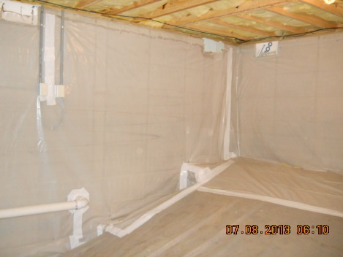

Encapsulating your crawlspace is one of the most important advances in design and construction technology in the last 400 years. It keeps your crawlspace and your entire house cleaner, healthier, drier, nearly 99% pest free and more energy efficient. And: it feels better and looks better. Read on to find out more…

Click below to see the article:
http://www.homearchitects.com/encapsulated-crawlspace

End of this edition.

© Copyright 2013 Home Architect, PLLC, All Rights Reserved Worldwide
HOME ARCHITECTS ®
1 . 828 . 269 . 9046
Rand@HomeArchitects.com
www.HomeArchitects.com

Anyone is hereby licensed to forward this e-magazine to anyone else, making no changes.

