HOME
ARCHITECTS ®
MAGAZINE

© Copyright 2013 Home Architect, PLLC, All Rights Reserved Worldwide
An online e-magazine affiliated with the HOME ARCHITECTS® website.
Editor: Rand Soellner, ArCH/NCARB/LHI.
HOME ARCHITECTS ®
1 . 828 . 269 . 9046
E-mail: Rand@HomeArchitects.com
Website: www.HomeArchitects.com
This issue electronically first published on 8/1/2013, from the United States of America.

Issue 17, September 2013

Hello Clients, prospective Clients & other people interested in home architecture.

You will find a brief summary about each online article, followed by a hotlink to that article. We usually will have about 3 to 6 online articles a month, contained within the latest e-magazine issue.

Click on the links (you may have to press your control key, then click the link) to be taken to those pages on your Internet browser. If you ever lose this e-magazine, just reopen the e-mail that contains it, or send us a request and we will promptly send you another. You may save it to your hard drive, if you wish.

If you think of an idea for a future story, let us know! We routinely create custom articles to answer questions of our subscribers.

You are welcome to contact us if you have any questions (about your project or our articles): 1-828-269-9046 or Rand@HomeArchitects.com .
We look forward to being your architect on your next project.

You are encouraged to forward this e-magazine along to other people.
Thank you for your interest.

Index for this issue:
- Fall House Maintenance: 10 things to do.
- What’s First: Architect or Builder?
- Site Selection & Site Planning

Fall House Maintenance: 10 things to do

Hard to believe that another fall is rolling around. It seemed like just a while ago we were entering spring and summer. What should you do to maintain your house for fall? 10 things are listed in this article. Read the article to discover more…

Click below to see the article:
http://www.homearchitects.com/fall-house-maintenance-10-things-to-do

What’s First: Architect or Builder?

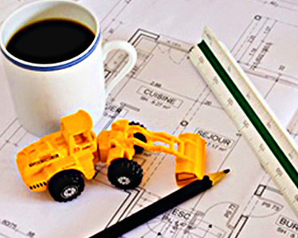

“What’s first: the Architect or the Builder?” The HOME ARCHITECTS ® once in a while receive an inquiry like this. The answer is: What’s first: the Design or the Construction? Which of course, means: you first need to have a Design before you can Build it. Read the online feature to find out more…

Click below to see the article:
http://www.homearchitects.com/whats-first-architect-or-builder

Site Selection & Site Planning

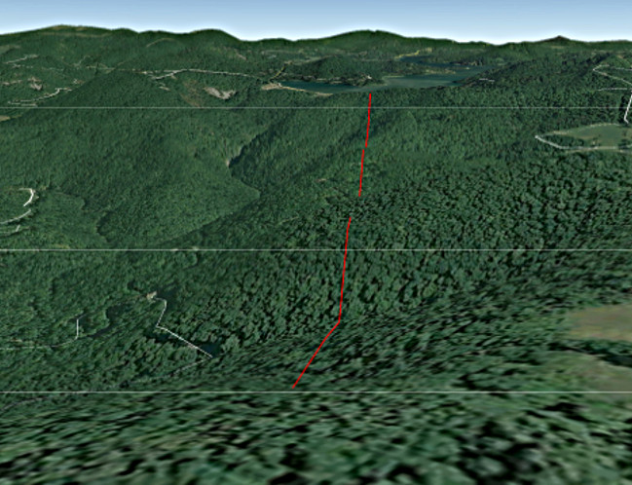

This Site Selection & Site Planning mark the beginning of the journey for many people who want to have a custom house designed and built for them. Read the article to learn more…

Click below to see the article:
http://www.homearchitects.com/site-selection-site-planning

End of this edition.

© Copyright 2013 Home Architect, PLLC, All Rights Reserved Worldwide
HOME ARCHITECTS ®
1 . 828 . 269 . 9046
Rand@HomeArchitects.com
www.HomeArchitects.com

Anyone is hereby licensed to forward this e-magazine to anyone else, making no changes.

