HOME
ARCHITECTS ®
MAGAZINE

© Copyright 2013 Home Architect, PLLC, All Rights Reserved Worldwide
An online e-magazine affiliated with the HOME ARCHITECTS® website.
Editor: Rand Soellner, Architect, ArCH/NCARB/LHI.
HOME ARCHITECTS ®
1 . 828 . 269 . 9046
E-mail: Rand@HomeArchitects.com
Website: www.HomeArchitects.com
This issue electronically first published on 11/25/2013, from the United States of America.

Issue 20, December 2013

Hello Clients, prospective Clients & other people interested in home architecture.

You will find a brief summary about each online article, followed by a hotlink to that article. We usually will have about 3 to 6 online articles a month, contained within the latest e-magazine issue.

Click on the links (you may or may not need to press your control key, then click the link) to be taken to those pages on your Internet browser. If you ever lose this e-magazine, just reopen the e-mail that contains it, or send us a request and we will promptly send you another. You may save it to your hard drive, if you wish.

If you think of an idea for a future story, let us know! We routinely create custom articles to answer questions of our subscribers.

You are welcome to contact us if you have any questions (about your project or our articles): 1-828-269-9046 or Rand@HomeArchitects.com .
We look forward to being your architect on your next project.

You are encouraged to forward this e-magazine along to other people.
Thank you for your interest & HAPPY HOLIDAYS!

Index for this issue:
- Why You Need a Survey
- Stone Lined Driveway
- How to Lose 10 to 20 Pounds in 3 months: 10 ideas
- Saving an Hour a Day : Good House Design
- Discoveries of the Firm

Why You Need a Survey

Some people are under the impression that when they have a house designed and built, that they do not need a survey. They are sorely mistaken. No matter how large your property is, you need a survey. Read on to understand why…

Click below to see the article:
http://www.homearchitects.com/why-you-need-a-survey

Stone Lined Driveway

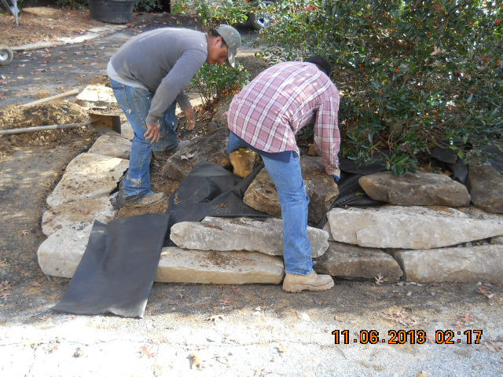

Many new homeowners find themselves wondering what to pave their driveways with and how to improve the aesthetics of that area. One solution is to have a stone lined driveway designed and managed by your Architect. Read the online feature to find out more…

Click below to see the article:
http://www.homearchitects.com/stone-lined-driveway

How to Lose 10 to 20 pounds in 3 months: 10 ideas

How to lose 10 to 20 pounds in 3 months: is that your goal? Well, Rand & Merry Soellner did just that. He’s an Architect and she’s a Real Estate Broker. This article features 10 ideas. None of them is hard or unpleasant. Read the article to learn more…

Click below to see the article:
http://www.homearchitects.com/how-to-lose-10-to-20-pounds-in-3-months-10-ideas

Saving an Hour a Day : Good House Design
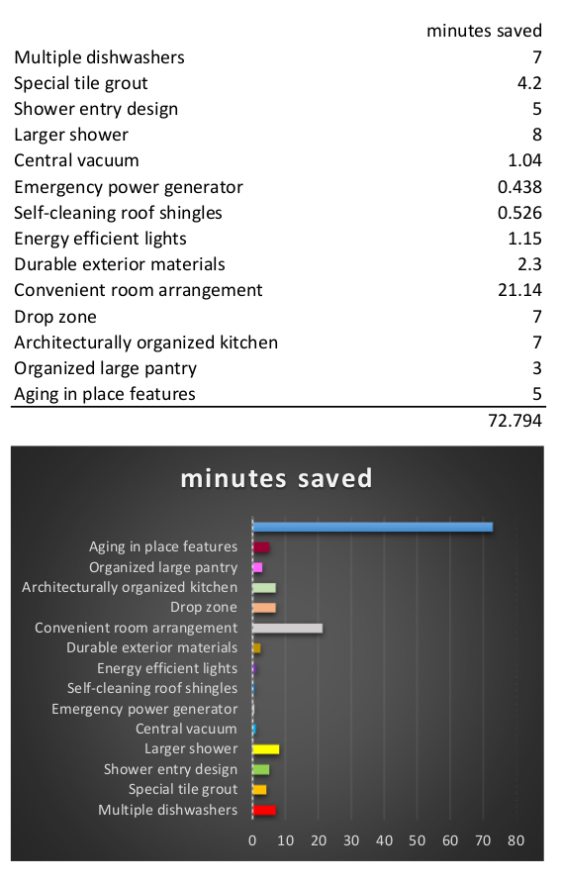

How can an architecturally- designed house save you an hour a day? Read this page to discover how an Architect can build in efficiency, durability and other time-saving features into your next residence.

Click below to see the article:
http://www.homearchitects.com/interesting-features/saving-an-hour-a-day-good-house-design

Discoveries of the Firm

Discoveries by the HOME ARCHITECTS ® include research & development of their own and facts uncovered that may have been developed by others. One of the company’s main efforts is to constantly update, refine & optimize architecture for its main purpose: housing design. Read the article to find our more…

Click below to see the article:
http://www.homearchitects.com/interesting-features/discoveries-of-the-firm

End of this edition.

© Copyright 2013 Home Architect, PLLC, All Rights Reserved Worldwide
HOME ARCHITECTS ®
1 . 828 . 269 . 9046
Rand@HomeArchitects.com
www.HomeArchitects.com

Anyone is hereby licensed to forward this e-magazine to anyone else, making no changes.

