HOME ARCHITECTS ®
e-Magazine
Issue 22
January 2014

© Copyright 2014 Home Architect, PLLC, All Rights Reserved Worldwide
An online e-magazine affiliated with the HOME ARCHITECTS® website.
Editor: Rand Soellner, Architect, ArCH/NCARB/LHI.
HOME ARCHITECTS ® 1 . 828 . 269 . 9046
E-mail: Rand@HomeArchitects.com Website:www.HomeArchitects.com
This issue electronically first published on 1/31/2014, from the USA.

Hello Clients, prospective Clients & other people interested in home architecture.

You will find a brief summary about each online article, including a photo with a hotlink to that article. We usually will have about 3 to 6 online articles a month, contained within the latest e-magazine issue.

Click on the photos (you may or may not need to press your control key, then click the link) to be taken to those pages on your Internet browser. If you ever lose this e-magazine, just reopen the e- mail that contains it, or send us a request and we will promptly send you another. You may save it to your hard drive, if you wish.

If you think of an idea for a future story, let us know! We routinely create custom articles to answer questions of our subscribers.

You are welcome to contact us if you have any questions about your project or our articles: 1-828-269-9046 or Rand@HomeArchitects.com . We look forward to being your Architect on your next project.

You are encouraged to forward this e-magazine along to other people. Thank you for your interest & patronage.

Index for this issue

This is an electronic magazine. You can click the article title that most interests you and that will roll up on your screen. You can also click “Back to Index” just under the right side border of each article to return to this Index. Depending on your version of MS Word, you may have to press Cntrl + Click.

- We Don’t Need No Stinking Badges
- Client Centered Architectural Design Process
- How to Hire a General Contractor
- How to Hire an Architect

We Don’t Need No Stinking Badges
Back to Index

“Badges? We don’t need no stinking badges!” So said the bandidos in the 1984 Michael Douglas/ Kathleen Turner movie “Romancing the Stone, ” also in Blazing Saddles, and they were both paying a misquoted homage to the 1948 Humphrey Bogart movie: “Treasure of the Sierra Madre.” Well, perhaps thieves in the middle of a jungle or desert, or unlicensed “designers” don’t need badges, but your Architect should have a few. Read on to understand why… (click the photo to see the article)

Client Centered Architectural Design
Process
Back to Index

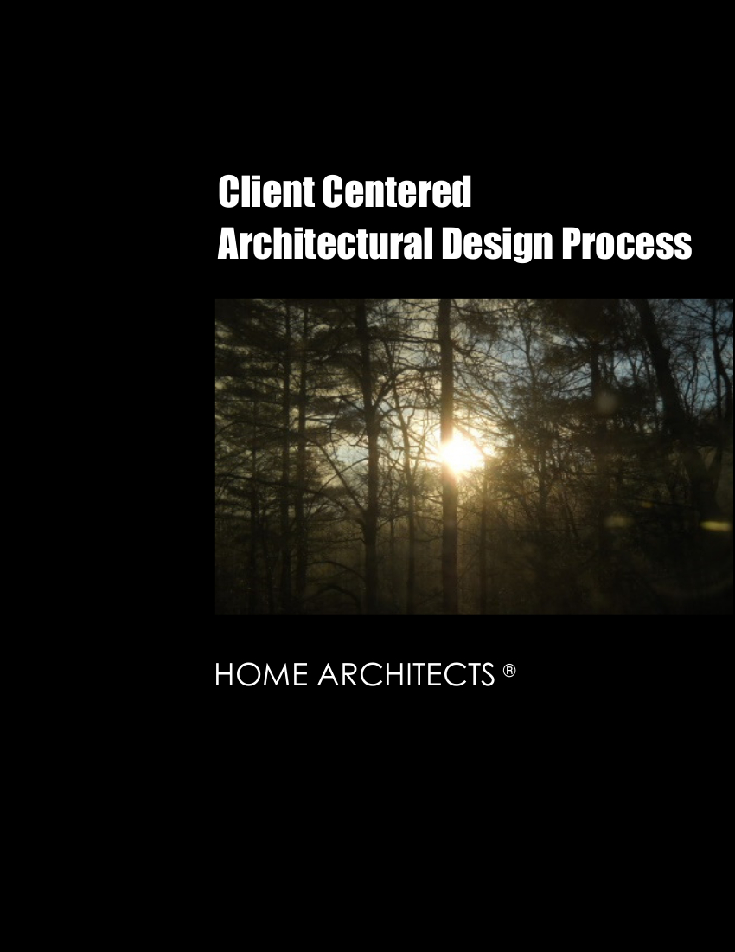

The Client Centered Architectural Design Process is the method by which the HOME ARCHITECTS ® create their projects for their clients. This title is also the name of the new 28-page mini-e-book written by the company to help their clients understand “what comes next?” Read the online feature story to find out more… (click the photo to see the article)

How to Hire a General Contractor
Back to Index

How to Hire a General Contractor is a new online mini-e-book, written by HOME ARCHITECTS ®.
It really won’t be available for general distribution until the new website format is up and running, as one of the premier features of that new format. That should be hopefully by March 2014. This preview, however, will allow you to download a free copy. Read the article to learn more… (click the photo to see the article)

How to Hire an Architect
Back to Index

How to Hire an Architect is a new online mini-e-book, written by HOME ARCHITECTS ®. This 30 page mini-e-book discusses the various considerations to make to lead you to hiring your Architect for your project. (click the photo to see the article)

Back to Index
End of this edition.

© Copyright 2014 Home Architect, PLLC, All Rights Reserved Worldwide
HOME ARCHITECTS ® 1 . 828 . 269 . 9046
Rand@HomeArchitects.com www.HomeArchitects.com

Anyone is hereby licensed & encouraged to forward this e-magazine to anyone else, making no changes.

