HOME ARCHITECTS ®
e-Magazine
Issue 24
March 2014

© Copyright 2014 Home Architect, PLLC, All Rights Reserved Worldwide
An online e-magazine affiliated with the HOME ARCHITECTS® website.
Editor: Rand Soellner, Architect, ArCH/NCARB/LHI.
HOME ARCHITECTS ® 1 . 828 . 269 . 9046
E-mail: Rand@HomeArchitects.com Website:www.HomeArchitects.com
This issue electronically first published on 4/2/2014, from the USA.

Hello Clients, prospective Clients & other people interested in home architecture.

You will find a brief summary about each online article, including a photo with a hotlink to that article. We usually will have about 3 to 6 online articles a month, contained within the latest e-magazine issue.

Click on the photos (you may or may not need to press your control key, then click the link) to be taken to those pages on your Internet browser. If you ever lose this e-magazine, just reopen the e- mail that contains it, or send us a request and we will promptly send you another. You may save it to your hard drive, if you wish.

If you think of an idea for a future story, let us know! We create custom articles to answer questions of our subscribers.

You are welcome to contact us if you have any questions about your project: 1-828-269-9046 or Rand@HomeArchitects.com . We look forward to being your Architect on your next project.

You are encouraged to forward this e-magazine along to other people. Thank you for your interest & patronage.

Technology comment: We are using state of the art 64-bit computers and 2013 software. If you have older equipment and software, you may not be receiving everything properly. We apologize for any inconvenience.

Index for this issue

This is an electronic magazine. You can click the article title that most interests you and that will roll up on your screen. You can also click “Back to Index” just under the right side border of each article to return to this Index. Depending on your version of MS Word, you may have to press Cntrl + Click.

- Link to Well-Detailed Construction Documents
- Link to Stairway Addition-Renovation
- Link to Top 8 Client Benefits

Well-Detailed Construction
Documents
Back to Index
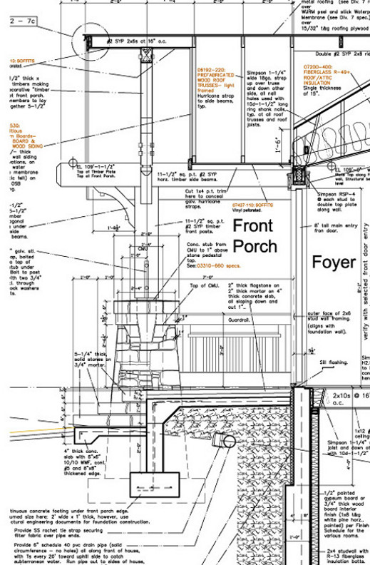

Well-detailed construction documents versus no details or otherwise skimpy sets of drawings. What’s the difference? Why should anyone care? That’s the subject of this article.
Read on to understand why… (click the photo to see the article. If no photo appears above, click the link below or copy and paste it into your browser)
http://www.homearchitects.com/well-detailed-construction-documents

Stairway Addition - Renovation
Back to Index

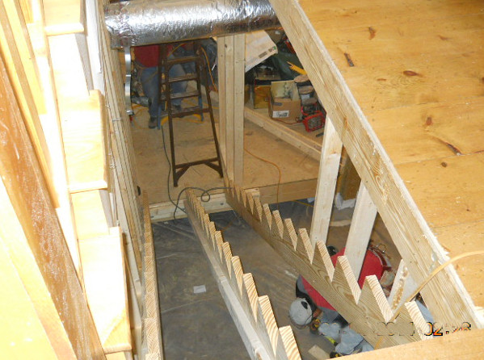

If you’re like some people, you may have space, even an unfinished floor, in a basement level with only exterior access. In other words, you can’t get into that basement unless you go outside and walk down a hill and then enter a walk-out door down there.
Read the online feature story to find out how to insert a new stairway into your existing house… (click the photo to see the article. If no photo appears above, click the link below or copy and paste it into your browser)
http://www.homearchitects.com/stairway-addition-renovation

Top 8 Client Benefits
Back to Index

The top 8 client benefits of having the HOME ARCHITECTS ® design your residential project are the subject of this article and video.
Read the article to learn more… (click the photo to see the article. If no photo appears above, click the link below or copy and paste it into your browser)
http://www.homearchitects.com/top+8+client+benefits

Back to Index
End of this edition.

© Copyright 2014 Home Architect, PLLC, All Rights Reserved Worldwide
HOME ARCHITECTS ® 1 . 828 . 269 . 9046
Rand@HomeArchitects.com www.HomeArchitects.com

Anyone is hereby licensed & encouraged to forward this e-magazine to anyone else, making no changes.

