HOME ARCHITECTS ®
e-Magazine
Issue 28
Aug 2014

© Copyright 2014 Home Architect, PLLC, All Rights Reserved Worldwide
An online e-magazine affiliated with the HOME ARCHITECTS® website.
Editor: Rand Soellner, Architect, ArCH/NCARB/LHI.
HOME ARCHITECTS ® 1 . 828 . 269 . 9046
E-mail: Rand@HomeArchitects.com Website:www.HomeArchitects.com
This issue electronically first published on 8/1/2014, from the USA.

Hello Clients, prospective Clients & other people interested in home architecture.

You will find a brief summary about each online article, including a photo with a hotlink to that article. We usually will have about 3 to 6 online articles a month, contained within the latest e-magazine issue.

Click on the photos (you may or may not need to press your control key, then click the link) to be taken to those pages on your Internet browser. If you ever lose this e-magazine, just reopen the e- mail that contains it, or send us a request and we will promptly send you another. You may save it to your hard drive, if you wish.

If you think of an idea for a future story, let us know! We create custom articles to answer questions of our subscribers.

You are welcome to contact us if you have any questions about your project: 1-828-269-9046 or Rand@HomeArchitects.com . We look forward to being your Architect on your next project.

You are encouraged to forward this e-magazine along to other people. Thank you for your interest & patronage.

Technology comment: We are using state of the art 64-bit computers and 2013-2015 software. If you have older equipment and software, you may not be receiving everything properly. We apologize for any inconvenience.

Index for this issue

This is an electronic magazine. You can click the article title that most interests you and that will roll up on your screen. You can also click “Back to Index” just under the right side border of each article to return to this Index. Depending on your version of MS Word, you may have to press Cntrl + Click.

- Link to Mountain Bird Residence Design
- Link to Architectural Project Management
- Link to 10 Mil Vapor Barrier
- Link to Frameless Glass Shower Enclosures

Mountain Bird Residence Design
Back to Index
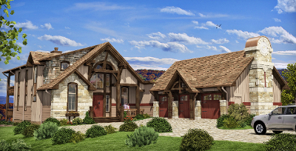

Mountain Bird is the latest project from the HOME ARCHITECTS. This well-crafted house design is situated in the Blue Ridge Mountains of Tennessee. The Client wanted a quality residential design but mid-sized.
Read on to discover more… (click the photo to see the article. If no photo appears above, click the link below or copy and paste it into your browser)
http://www.homearchitects.com/main-menu/projects/3-br-homes-index/mountain-bird-residence-design

e-magazine continued below:

Architectural Project Managment
Back to Index

Architectural Project Management services are optional services provided for you by HOME ARCHITECTS ®, in addition to their Basic Services and in addition to their other Additional Services. This firm’s optional Project Management services (your option to have them or not) includes a host of helpful activities that you probably cannot do for yourself…
Read the online feature story to find out more… (click the photo to see the article. If no photo appears above, click the link below or copy and paste it into your browser)
http://www.homearchitects.com/architectural-project-management

10 Mil Vapor Barrier
Back to Index
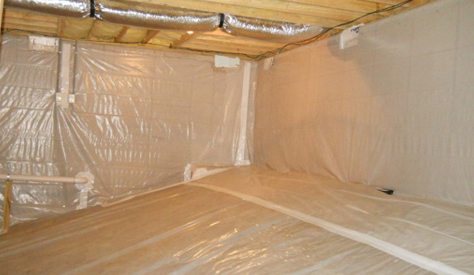

10 mil vapor barrier: that’s probably not exciting news to you if you’re not an Architect or Contractor. Yawn… However, if you ARE an Architect or Contractor, this is big news.
Read the article to learn more… (click the photo to see the article. If no photo appears above, click the link below or copy and paste it into your browser).
http://www.homearchitects.com/10-mil-vapor-barrier

Frameless Glass Shower Enclosures
Back to Index
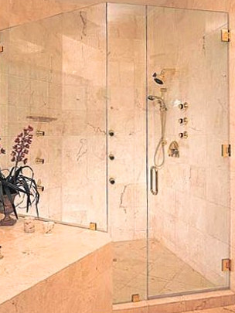

Frameless glass shower enclosures is a hot design subject these days. HOME ARCHITECTS ® is providing them in their projects; the latest in a spectacular house for a Client in Tennessee.
Read the article for more information. (click the photo to see the article. If no photo appears above, click the link below or copy and paste it into your browser).
http://www.homearchitects.com/frameless-glass-shower-enclosures

Back to Index
End of this edition.

© Copyright 2014 Home Architect, PLLC, All Rights Reserved Worldwide
HOME ARCHITECTS ® 1 . 828 . 269 . 9046
Rand@HomeArchitects.com www.HomeArchitects.com

Anyone is hereby licensed & encouraged to forward this e-magazine to anyone else, making no changes.

