HOME
ARCHITECTS ®
MAGAZINE

© Copyright 2012 Home Architect, PLLC, All Rights Reserved Worldwide
An online e-magazine affiliated with the HOME ARCHITECTS® website.
Editor: Rand Soellner, AIA/NCARB/LHI.
HOME ARCHITECTS ®
1 . 828 . 269 . 9046
E-mail: Rand@HomeArchitects.com
Website: www.HomeArchitects.com
This issue electronically first published on 7/2/2012, from the United States of America.

Issue 3, July 2012

Hello Clients, prospective Clients & other people interested in home architecture.

You will find a brief summary about each online article, followed by a hotlink to that article. We usually will have about 3 to 6 online articles a month, contained within the latest e-magazine issue.

Just click on the links (you may have to press your control key, then click the link) to be taken to those pages on your Internet browser. If you ever lose this e-magazine, just reopen the e-mail that contains it, or send us a request and we will promptly send you another. You may save it to your hard drive, if you wish.

You are welcome to contact us if you have any questions (about your project or our articles): 1-828-269-9046 or Rand@HomeArchitects.com .
We hope to be your architect on your next project.

You are encouraged to forward this e-magazine along to other people.
Thank you for your interest.

Basement Wall Waterproofing
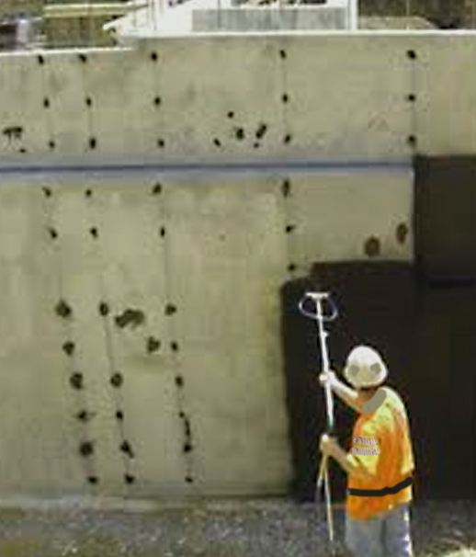

Many of our clients are considering having a WALKOUT BASEMENT or other subterranean space in their new home design. We design these all the time at the HOME ARCHITECTS ®. This requires careful detailing and specifying to insure that your basement walls will remain dry and resist water penetration. MOST BASEMENT WALLS LEAK, and grow mold in people’s basements, except for ours. Why? Take a look at this online article to find out:

http://www.homearchitects.com/basement-wall-waterproofing

Housing Economy Upturn 2012

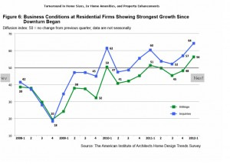

You may often wonder “WHEN IS A GOOD TIME TO BUILD MY HOUSE?” or other similar situation, such as obtaining a loan, or managing the design and construction of a renovation. The AIA (American Institute of Architects) is indicating the Strongest Housing Growth in 6 Years. See more by clicking on the link below:

http://www.homearchitects.com/housing-economy-upturn-2012

Mountain Weather

We have had a good long run of delightful mountain weather (update: until this last week, when things got warmer for a while). Even our little Maltese has enjoyed her outdoor walks (yes, that’s Bitsy, otherwise known as “BearKiller.” All 9 pounds of her. Find out more about the Alpine Rain Forest ecology in the Blue Ridge Mountains, and some of our history by clicking on the link below.

http://www.homearchitects.com/mountain-weather

Windows and Minimum Code

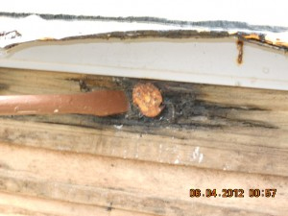

Living in your mountain home should be an enjoyable experience, in which your home mainly takes care of you, shelters you and allows you to have a good life.
Unfortunately, there are some weak spots inherent in Building Codes and construction practices that can turn this dream of new home ownership into a nightmare. For instance, LEAKING WINDOWS.

Most people trust their contractor and building department and building codes to protect them. This will not work for many things, such as your windows, and you may wonder why an architect should be involved in this. We also function as Forensic Architects, analyzing other people’s problems and why building components fail and leak and rot (typically on buildings and homes that we did Not design). This is a very important online article and reading it just might save you anywhere from $50,000 to $200,000 depending on your house. Click on the link below:

http://www.homearchitects.com/windows-and-minimum-code

End of this edition.

© Copyright 2012 Home Architect, PLLC, All Rights Reserved Worldwide
HOME ARCHITECTS ®
1 . 828 . 269 . 9046
Rand@HomeArchitects.com
www.HomeArchitects.com

Anyone is hereby licensed to forward this e-magazine to anyone else, making no changes.

