HOME
ARCHITECTS ®
MAGAZINE

© Copyright 2012 Home Architect, PLLC, All Rights Reserved Worldwide
An online e-magazine affiliated with the HOME ARCHITECTS® website.
Editor: Rand Soellner, AIA/NCARB/LHI.
HOME ARCHITECTS ®
1 . 828 . 269 . 9046
E-mail: Rand@HomeArchitects.com
Website: www.HomeArchitects.com
This issue electronically first published on 8/5/2012, from the United States of America.

Issue 4, August 2012

Hello Clients, prospective Clients & other people interested in home architecture.

You will find a brief summary about each online article, followed by a hotlink to that article. We usually will have about 3 to 6 online articles a month, contained within the latest e-magazine issue.

Just click on the links (you may have to press your control key, then click the link) to be taken to those pages on your Internet browser. If you ever lose this e-magazine, just reopen the e-mail that contains it, or send us a request and we will promptly send you another. You may save it to your hard drive, if you wish.

You are welcome to contact us if you have any questions (about your project or our articles): 1-828-269-9046 or Rand@HomeArchitects.com .
We hope to be your architect on your next project.

You are encouraged to forward this e-magazine along to other people.
Thank you for your interest.

Sealing Your Attic Against Air Leaks

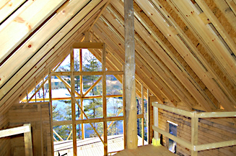

One of the big AIR leak locations in many people’s homes is their attic/roof/ceiling leaking air in and out. This article discusses what can be done to prevent the problem, if the HOME ARCHITECTS ® are designing your house, or what can be done to improve your present situation.

Click below to see the article:
http://www.homearchitects.com/sealing-your-attic-against-air-leaks

5 Reasons for an Architect to Design your House

Our firm: HOME ARCHITECTS ® has over 40 reasons why it is a very good idea to have a licensed architect design your house. However, that may be a bit much for some folks. So, here are 5 easy to understand reasons that may make sense to you.

Click below to see the article:
http://www.homearchitects.com/5-reasons-for-an-architect-to-design-your-house

Kitchen Renovations

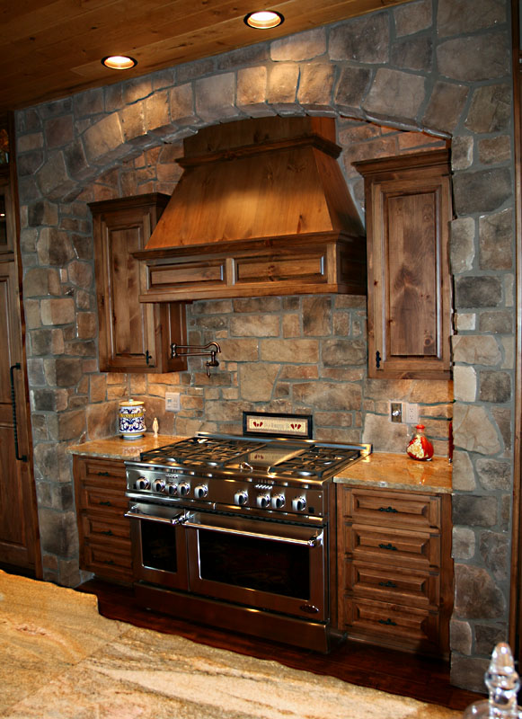

Lots of people like to renovate their kitchens. The image above actually is from one of the HOME ARCHITECTS ® custom homes (in the Sevier County, Tennessee area). However, it displays one the most sought-after features, even in renovations: a stone arch and stone side walls and backsplash. Very nice! This particular article looks at several kitchen renovation projects, illustrating how cramped, existing gallery kitchens can be turned into spacious creative cooking spaces that can fit the whole family.

Click below to see the article:
http://www.homearchitects.com/kitchen-renovations

ICF : Insulated Concrete Forms for Houses

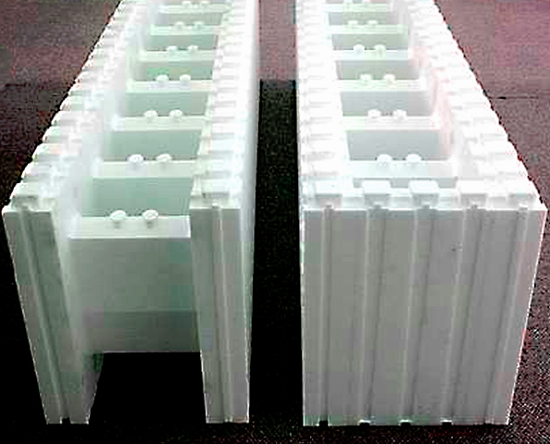

Several of our clients have asked to have home foundations formed of ICF: Insulated Concrete Forms. These are lightweight white plastic blocks that click together like Legos. You add steel reinforcing, brace them, add additional forms at door and window openings, then pump concrete into them. We are doing one such project right now, for a Forensic Structural Engineer in Pennsylvania. He consults with large institutions when there are structural problems on large facilities. Out of all the architects in the World that he could have selected to design his own family’s house, he picked: HOME ARCHITECTS ®. Rand Soellner, ArCH, NCARB, the firm’s senior architect, feels honored to have been selected.

Click below to see the article:
http://www.homearchitects.com/icf-insulated-concrete-forms-for-houses

Design & Construction Summary Pathfinder for Clients

This is a summary of our new website format preview of our special “White Paper” download detailing the architectural design and construction process for clients. This online summary previews the main topics involved with the process. Many clients don’t have any idea of what lays before them. This might help get you going and give you an idea of what will happen. Our new website format is being worked on and we expect it to be online within a couple of weeks or so. We’ll see. The programmers are hard at it. After it is online, the entire 16-page process will become downloadable.

Click below to see the article:
http://www.homearchitects.com/design-construction-summary-pathfinder-for-clients

End of this edition.

© Copyright 2012 Home Architect, PLLC, All Rights Reserved Worldwide
HOME ARCHITECTS ®
1 . 828 . 269 . 9046
Rand@HomeArchitects.com
www.HomeArchitects.com

Anyone is hereby licensed to forward this e-magazine to anyone else, making no changes.

