HOME
ARCHITECTS ®
MAGAZINE

© Copyright 2012 Home Architect, PLLC, All Rights Reserved Worldwide
An online e-magazine affiliated with the HOME ARCHITECTS® website.
Editor: Rand Soellner, AIA/NCARB/LHI.
HOME ARCHITECTS ®
1 . 828 . 269 . 9046
E-mail: Rand@HomeArchitects.com
Website: www.HomeArchitects.com
This issue electronically first published on 11/1/2012, from the United States of America.

Issue 7, November 2012

Hello Clients, prospective Clients & other people interested in home architecture.

You will find a brief summary about each online article, followed by a hotlink to that article. We usually will have about 3 to 6 online articles a month, contained within the latest e-magazine issue.

Just click on the links (you may have to press your control key, then click the link) to be taken to those pages on your Internet browser. If you ever lose this e-magazine, just reopen the e-mail that contains it, or send us a request and we will promptly send you another. You may save it to your hard drive, if you wish.

If you ever think of an idea for a future story, let us know! We routinely create custom articles to answer the questions of our subscribers.

You are welcome to contact us if you have any questions (about your project or our articles): 1-828-269-9046 or Rand@HomeArchitects.com .
We hope to be your architect on your next project.

You are encouraged to forward this e-magazine along to other people.
Thank you for your interest.

Good Residential Architecture Keeps You Alive

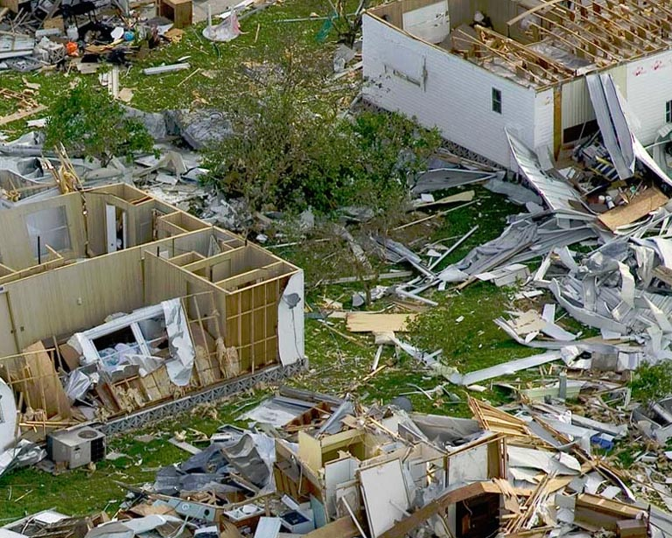

Hurricane Sandy has taught us another lesson: that is: if any of us are listening. Not until a huge storm kills tens, hundreds or thousands of people do building codes and state and Federal laws change. The fact is: good residential architectural keeps you and your family alive. Read the article to learn more about you can come home to your house instead of an empty lot after the next big storm.…

Click below to see the article:
http://www.homearchitects.com/good-residential-architecture-keeps-you-alive

Architect Helping Hurricane Sandy Victims

Rand Soellner, AIA of the firm, said that “These people have suffered enough. The least we can do is to help by designing new houses for them to replace those that they lost.” Read more in the article …

Click below to see the article:
http://www.homearchitects.com/architect-helping-hurricane-sandy-victims

Skype Communications on Architect Website

HOME ARCHITECTS ® have included another exciting communication method on their new website format: Skype. The firm’s Skype button can be found on the right side, in the upper region of the website. See the article to learn more…

Click below to see the article:
http://www.homearchitects.com/skype-communications-on-architect-website

Outdoor Living Rooms

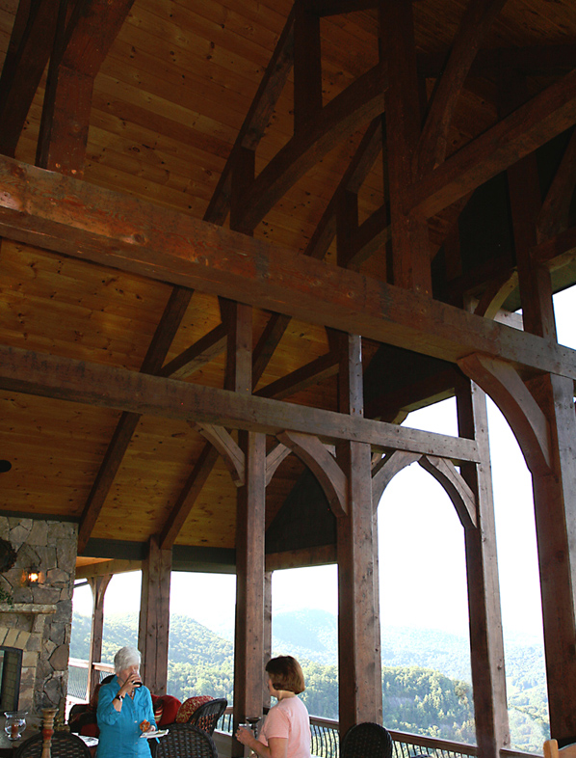

Every client wants an outdoor living room. Everyone wants the outside to come inside and to be able to enjoy living in their outdoor space. How do the Home Architects ® do this? Read the article to find out .…

Click below to see the article:
http://www.homearchitects.com/outdoor-living-rooms

End of this edition.

© Copyright 2012 Home Architect, PLLC, All Rights Reserved Worldwide
HOME ARCHITECTS ®
1 . 828 . 269 . 9046
Rand@HomeArchitects.com
www.HomeArchitects.com

Anyone is hereby licensed to forward this e-magazine to anyone else, making no changes.

