HOME
ARCHITECTS ®
MAGAZINE

© Copyright 2012 Home Architect, PLLC, All Rights Reserved Worldwide
An online e-magazine affiliated with the HOME ARCHITECTS® website.
Editor: Rand Soellner, AIA/NCARB/LHI.
HOME ARCHITECTS ®
1 . 828 . 269 . 9046
E-mail: Rand@HomeArchitects.com
Website: www.HomeArchitects.com
This issue electronically first published on 12/2/2012, from the United States of America.

Issue 8, December 2012

Hello Clients, prospective Clients & other people interested in home architecture.

You will find a brief summary about each online article, followed by a hotlink to that article. We usually will have about 3 to 6 online articles a month, contained within the latest e-magazine issue.

Just click on the links (you may have to press your control key, then click the link) to be taken to those pages on your Internet browser. If you ever lose this e-magazine, just reopen the e-mail that contains it, or send us a request and we will promptly send you another. You may save it to your hard drive, if you wish.

If you ever think of an idea for a future story, let us know! We routinely create custom articles to answer the questions of our subscribers.

You are welcome to contact us if you have any questions (about your project or our articles): 1-828-269-9046 or Rand@HomeArchitects.com .
We hope to be your architect on your next project.

You are encouraged to forward this e-magazine along to other people.
Thank you for your interest.

Bunkrooms & Barn Doors

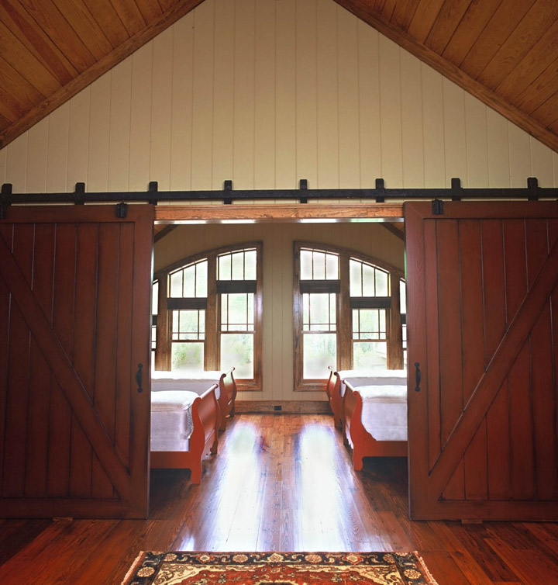

The HOME ARCHITECTS ® often have requests from their clients to design bunkrooms into basement levels or at lofts. These larger bedrooms are intended to be the sleeping rooms for groups of young people. Read the article to learn more about how barn doors factor into this for a creative approach to your next residential project.…

Click below to see the article:
http://www.homearchitects.com/bunkrooms-barn-doors

New Wall Technology: SupR-wall

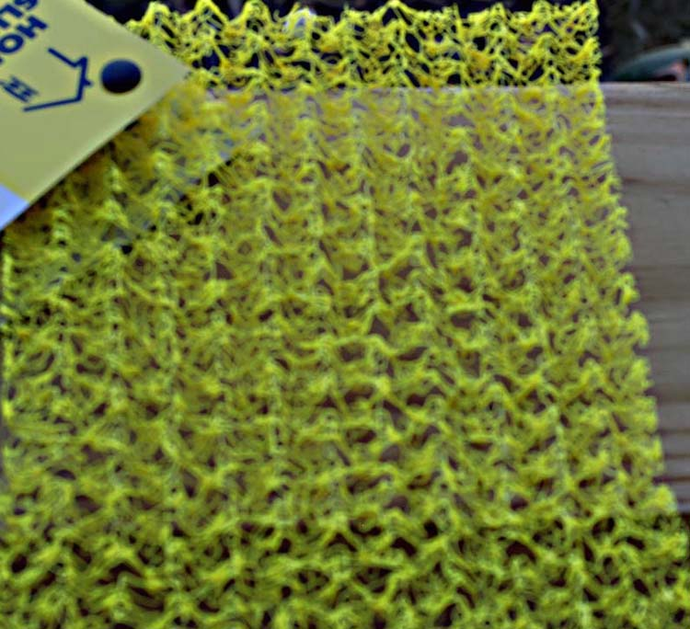

The HOME ARCHITECTS ® continuously reviews improvements in residential architectural technology to improve your next house. This online article includes the company’s new SupR-wall ™. Read more in the article …

Click below to see the article:
http://www.homearchitects.com/new-wall-technology-supr-wall

Long Pine Estate – One Story

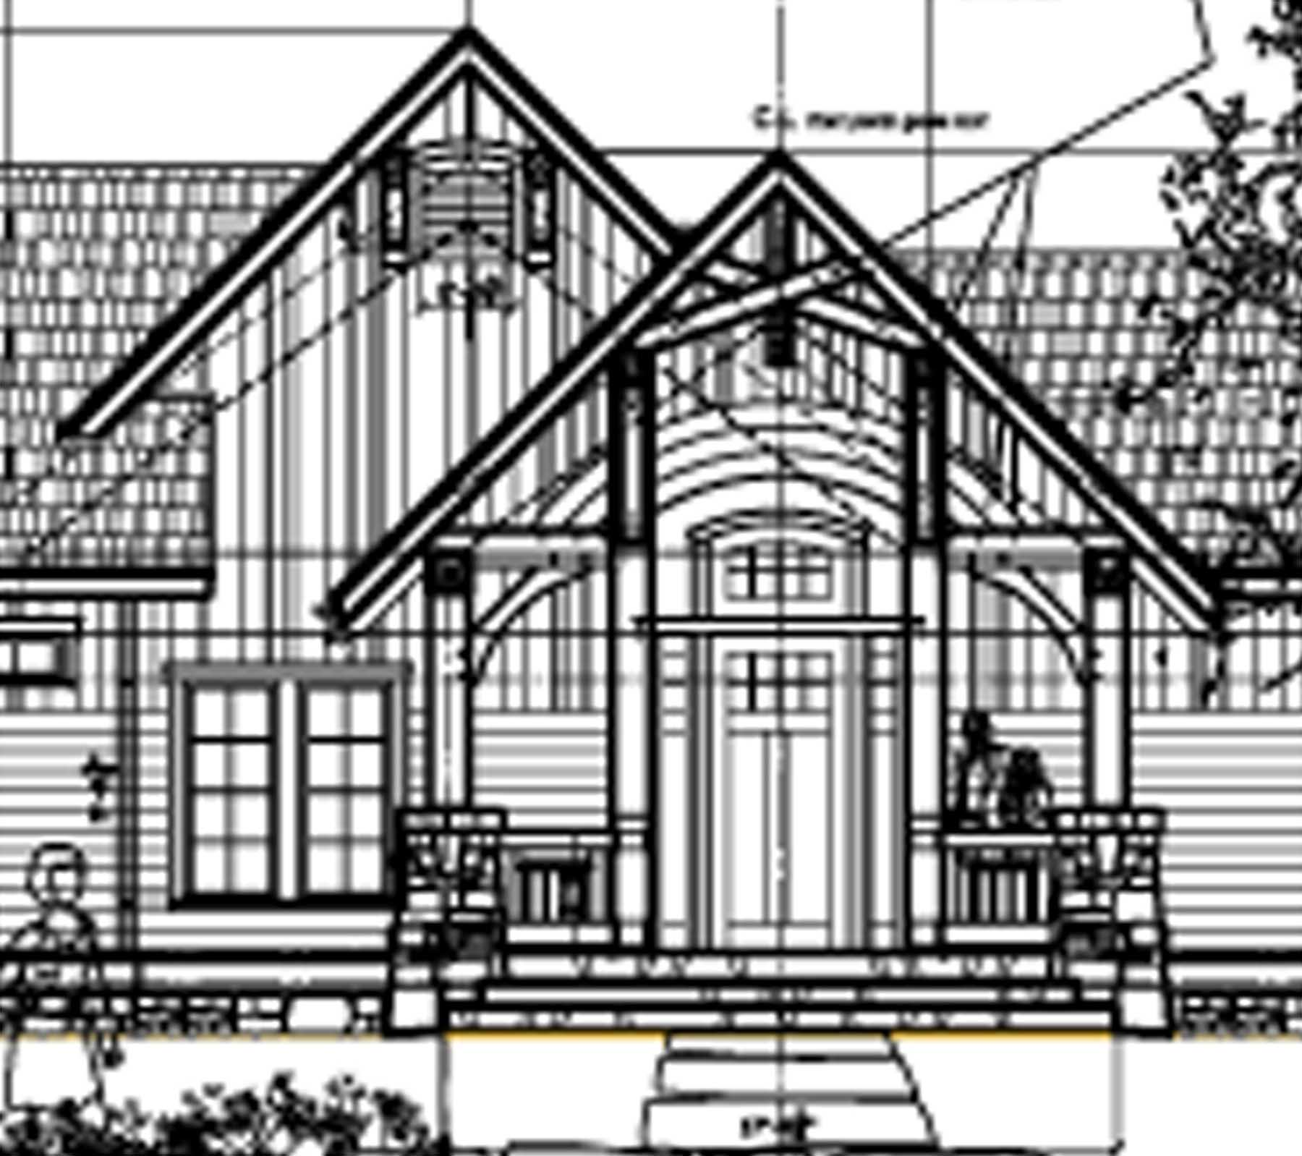

This one-story design can be thought of as a 4 Bedroom or a 3 Bedroom + Home Office concept. So, this can be interpreted as a 4BR/3Ba home. Or it could be thought of as a 3BR/2 Ba house. Why? See the article to learn more…

Click below to see the article:
http://www.homearchitects.com/long-pine-estate-one-story

Licensed Architect : What That Means

There are things happening these days that are Not in the best interests of the Health, Safety & Welfare of the public. Things about non-professional entities using the title “Architect.” There are those in our society that seek to confuse the public about what it means to be an architect. Read the article to find out how you can identify real, licensed architects and distinguish them from the frauds…

Click below to see the article:
http://www.homearchitects.com/licensed-architect-what-that-means

End of this edition.

© Copyright 2012 Home Architect, PLLC, All Rights Reserved Worldwide
HOME ARCHITECTS ®
1 . 828 . 269 . 9046
Rand@HomeArchitects.com
www.HomeArchitects.com

Anyone is hereby licensed to forward this e-magazine to anyone else, making no changes.

