HOME
ARCHITECTS ®
MAGAZINE

© Copyright 2013 Home Architect, PLLC, All Rights Reserved Worldwide
An online e-magazine affiliated with the HOME ARCHITECTS® website.
Editor: Rand Soellner, ArCH/NCARB/LHI.
HOME ARCHITECTS ®
1 . 828 . 269 . 9046
E-mail: Rand@HomeArchitects.com
Website: www.HomeArchitects.com
This issue electronically first published on 5/12/2013, from the United States of America.

Issue 13, May 2013

Hello Clients, prospective Clients & other people interested in home architecture.

You will find a brief summary about each online article, followed by a hotlink to that article. We usually will have about 3 to 6 online articles a month, contained within the latest e-magazine issue.

Click on the links (you may have to press your control key, then click the link) to be taken to those pages on your Internet browser. If you ever lose this e-magazine, just reopen the e-mail that contains it, or send us a request and we will promptly send you another. You may save it to your hard drive, if you wish.

If you think of an idea for a future story, let us know! We routinely create custom articles to answer questions of our subscribers.

You are welcome to contact us if you have any questions (about your project or our articles): 1-828-269-9046 or Rand@HomeArchitects.com .
We hope to be your architect on your next project.

You are encouraged to forward this e-magazine along to other people.
Thank you for your interest.

Why an Architect Should Design Your House

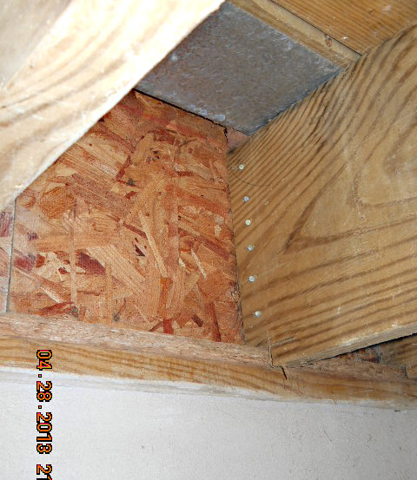

Rand Soellner, Architect, ArCH, NCARB, LHI, is both a licensed Architect and a Licensed Home Inspector. He sees things whenever he inspects someone’s house that he shakes his head at, wondering what the people building the house were thinking. He has come to the conclusion that just about the only way you can avoid major (and minor) problems with your house is to have an Architect design, detail and specify it. Read the article to find out more…

Click below to see the article:
http://www.homearchitects.com/why-an-architect-should-design-your-house

Value of an Architect: Lighting

This is part of a continuing series of online articles explaining the Value of an Architect. This series uses hard cold cash numbers to explain why your using an Architect to design your house can pay you back many times over the Architect’s fee.. Read on to find out how…

Click below to see the article:
http://www.homearchitects.com/value-of-an-architect-lighting

Value of an Architect: Roofing

There is a great VALUE in having a licensed Architect design your house. Specifically, this is the first in a series of online articles, looking at hard numbers and how those indicate that having a knowledgeable residential Architect design your house will SAVE you many times the cost of their services over the life of your residence. Read on to find out…

Click below to see the article:
http://www.homearchitects.com/value-of-an-architect-roofing

God is in the Details

An Architect invented that phrase: Ludwig Mies Van der Rohe. And he was correct: buildings and houses live and die by good or bad details. Rand Soellner, Senior Staff Architect of the architectural firm: HOME ARCHITECTS ® agrees that good detailing is essential to durable, properly functioning houses. Keep reading to learn more…

Click below to see the article:
http://www.homearchitects.com/god-is-in-the-details

End of this edition.

© Copyright 2013 Home Architect, PLLC, All Rights Reserved Worldwide
HOME ARCHITECTS ®
1 . 828 . 269 . 9046
Rand@HomeArchitects.com
www.HomeArchitects.com

Anyone is hereby licensed to forward this e-magazine to anyone else, making no changes.

