HOME
ARCHITECTS ®
MAGAZINE

© Copyright 2013 Home Architect, PLLC, All Rights Reserved Worldwide
An online e-magazine affiliated with the HOME ARCHITECTS® website.
Editor: Rand Soellner, ArCH/NCARB/LHI.
HOME ARCHITECTS ®
1 . 828 . 269 . 9046
E-mail: Rand@HomeArchitects.com
Website: www.HomeArchitects.com
This issue electronically first published on 7/1/2013, from the United States of America.

Issue 15, July 2013

Hello Clients, prospective Clients & other people interested in home architecture.

You will find a brief summary about each online article, followed by a hotlink to that article. We usually will have about 3 to 6 online articles a month, contained within the latest e-magazine issue.

Click on the links (you may have to press your control key, then click the link) to be taken to those pages on your Internet browser. If you ever lose this e-magazine, just reopen the e-mail that contains it, or send us a request and we will promptly send you another. You may save it to your hard drive, if you wish.

If you think of an idea for a future story, let us know! We routinely create custom articles to answer questions of our subscribers.

You are welcome to contact us if you have any questions (about your project or our articles): 1-828-269-9046 or Rand@HomeArchitects.com .
We look forward to being your architect on your next project.

You are encouraged to forward this e-magazine along to other people.
Thank you for your interest.

House Loan Interest Rates Rising
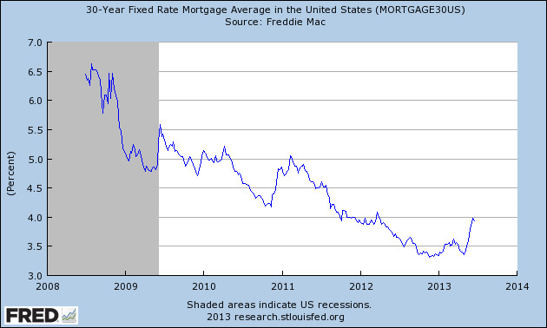

House loan interest rates are rising. If you’re like millions of other marker-watchers, waiting for rates to hit bottom: guess what? They did that several weeks ago. Now they are rising.
Read the article to find out more…

Click below to see the article:
http://www.homearchitects.com/house-loan-interest-rates-rising

A Slice of Heaven

As you walk along the quiet morning road outside your new house you gaze up at the sky, now turning lighter with the promise of the Sun. Stirrings in the trees herald blue jays, sparrows and wrens waking to the new day,
Read on to find out more…

Click below to see the article:
http://www.homearchitects.com/a-slice-of-heaven

Welcome to the Cabin

Welcome to the Cabin! That’s the phrase many have seen memorialized on wooden signs outside of many people’s houses they have bought or built as their vacation getaway. Read on to find out why…

Click below to see the article:
http://www.homearchitects.com/welcome-to-the-cabin

End of this edition.

© Copyright 2013 Home Architect, PLLC, All Rights Reserved Worldwide
HOME ARCHITECTS ®
1 . 828 . 269 . 9046
Rand@HomeArchitects.com
www.HomeArchitects.com

Anyone is hereby licensed to forward this e-magazine to anyone else, making no changes.

