HOME
ARCHITECTS ®
MAGAZINE

© Copyright 2013 Home Architect, PLLC, All Rights Reserved Worldwide
An online e-magazine affiliated with the HOME ARCHITECTS® website.
Editor: Rand Soellner, Architect, ArCH/NCARB/LHI.
HOME ARCHITECTS ®
1 . 828 . 269 . 9046
E-mail: Rand@HomeArchitects.com
Website: www.HomeArchitects.com
This issue electronically first published on 10/27/2013, from the United States of America.

Issue 19, November 2013

Hello Clients, prospective Clients & other people interested in home architecture.

You will find a brief summary about each online article, followed by a hotlink to that article. We usually will have about 3 to 6 online articles a month, contained within the latest e-magazine issue.

Click on the links (you may have to press your control key, then click the link) to be taken to those pages on your Internet browser. If you ever lose this e-magazine, just reopen the e-mail that contains it, or send us a request and we will promptly send you another. You may save it to your hard drive, if you wish.

If you think of an idea for a future story, let us know! We routinely create custom articles to answer questions of our subscribers.

You are welcome to contact us if you have any questions (about your project or our articles): 1-828-269-9046 or Rand@HomeArchitects.com .
We look forward to being your architect on your next project.

You are encouraged to forward this e-magazine along to other people.
Thank you for your interest.

Index for this issue:
- Reading Architects’ Documents
- Precision Design Documents
- Competence & Trustworthiness: Designing Houses

Reading Architects’ Documents

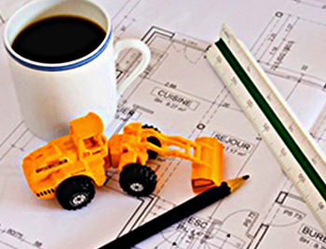

Reading Architects’ documents can be a challenge, unless educated in how that profession organizes the information. This article provides highlights of that organization. Read the article to discover more…

Click below to see the article:
http://www.homearchitects.com/reading-architects-documents

Precision Design Documents

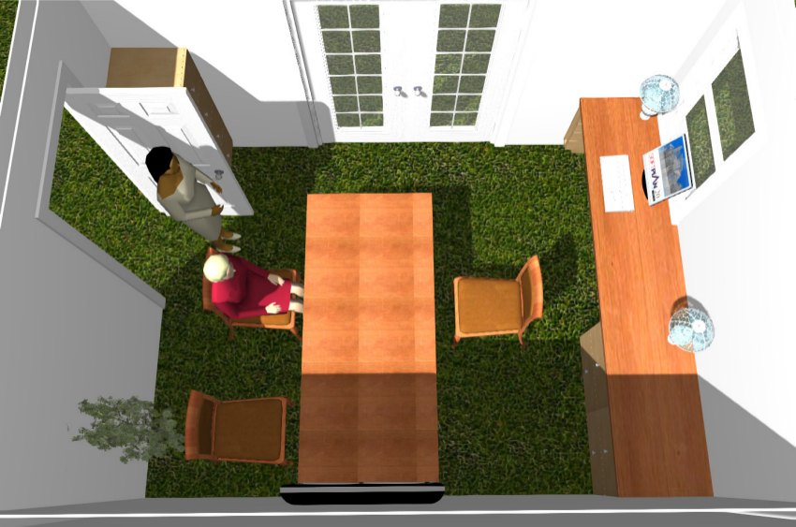

HOME ARCHITECTS ® heartily recommends builders that want detailed documents. This architectural firm has found that everyone knows the results much better with this approach… Read the online feature to find out more…

Click below to see the article:
http://www.homearchitects.com/precision-design-documents

Competence & Trustworthiness : Designing Houses

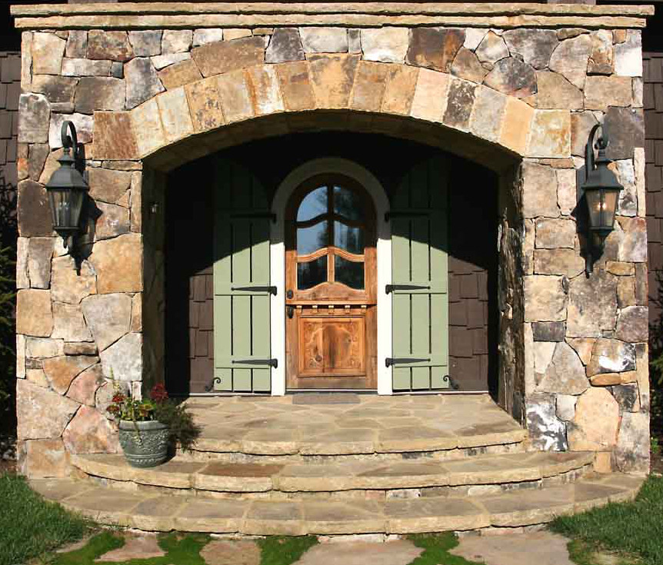

How and why should trustworthiness and competence enter into the equation of who is designing houses for you and others? Read the article to learn more…

Click below to see the article:
http://www.homearchitects.com/competence-trustworthiness-designing-houses

End of this edition.

© Copyright 2013 Home Architect, PLLC, All Rights Reserved Worldwide
HOME ARCHITECTS ®
1 . 828 . 269 . 9046
Rand@HomeArchitects.com
www.HomeArchitects.com

Anyone is hereby licensed to forward this e-magazine to anyone else, making no changes.

