HOME ARCHITECTS ®
e-Magazine
Issue 21
January 2014

© Copyright 2013 Home Architect, PLLC, All Rights Reserved Worldwide
An online e-magazine affiliated with the HOME ARCHITECTS® website.
Editor: Rand Soellner, Architect, ArCH/NCARB/LHI.
HOME ARCHITECTS ® 1 . 828 . 269 . 9046
E-mail: Rand@HomeArchitects.com Website:www.HomeArchitects.com
This issue electronically first published on 12/26/2013, from the USA.

Hello Clients, prospective Clients & other people interested in home architecture.

You will find a brief summary about each online article, including a photo with a hotlink to that article. We usually will have about 3 to 6 online articles a month, contained within the latest e-magazine issue.

Click on the photos (you may or may not need to press your control key, then click the link) to be taken to those pages on your Internet browser. If you ever lose this e-magazine, just reopen the e- mail that contains it, or send us a request and we will promptly send you another. You may save it to your hard drive, if you wish.

If you think of an idea for a future story, let us know! We routinely create custom articles to answer questions of our subscribers.

You are welcome to contact us if you have any questions about your project or our articles: 1-828-269-9046 or Rand@HomeArchitects.com . We look forward to being your Architect on your next project.

You are encouraged to forward this e-magazine along to other people. Thank you for your interest & HAPPY NEW YEAR !
You may have noticed that we have a new format for the new year, reflecting our recently updated logo & website; thank you for the positive comments.

Index for this issue

This is an electronic magazine. You can click the article title that most interests you and that will roll up on your screen. You can also click “Back to Index” just under the right side border of each article to return to this Index.

- Master Planning
- Walk Your Land with the Architect
- Start the Adventure
- New Website Format Coming

Master Planning
Back to Index

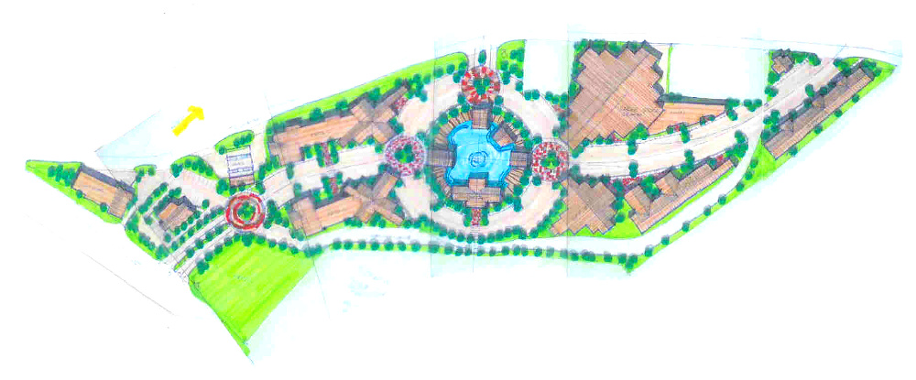

Master Planning refers to Master Site Planning. This is the service wherein you and your Architect discuss your intended uses for your land into the future for as far as you want to take the project.
Read on to understand why… (click the photo to see the article)

Walk Your Land with the Architect
Back to Index

Walking your land with the Architect ranks up among the most important activities for many land owners today. There is something magical about having the person who will design your house (and other possibly more substantial project) there, with you, treading on the sacred ground that you own. Read the online feature to find out more… (click the photo to see the article)

Start the Adventure
Back to Index

Start The Adventure is a bold new feature on the upcoming, soon-to-be released, new HOME ARCHITECTS ® website format. It is all about starting the adventure of a lifetime: beginning your new architectural project. Read the article to learn more…(click the photo to see the article)

New Website Format Coming
Back to Index

HOME ARCHITECTS ® has been redesigning its website during the last 1-1/2 months. The firm has analyzed what users of the site enjoy, like & need and is providing those upgrades. (click the photo to see the article)

Back to Index
End of this edition.

© Copyright 2013 Home Architect, PLLC, All Rights Reserved Worldwide
HOME ARCHITECTS ® 1 . 828 . 269 . 9046
Rand@HomeArchitects.com www.HomeArchitects.com

Anyone is hereby licensed & encouraged to forward this e-magazine to anyone else, making no changes.

