HOME ARCHITECTS ®
e-Magazine
Issue 23
March 2014

© Copyright 2014 Home Architect, PLLC, All Rights Reserved Worldwide
An online e-magazine affiliated with the HOME ARCHITECTS® website.
Editor: Rand Soellner, Architect, ArCH/NCARB/LHI.
HOME ARCHITECTS ® 1 . 828 . 269 . 9046
E-mail: Rand@HomeArchitects.com Website:www.HomeArchitects.com
This issue electronically first published on 3/1/2014, from the USA.

Hello Clients, prospective Clients & other people interested in home architecture.

You will find a brief summary about each online article, including a photo with a hotlink to that article. We usually will have about 3 to 6 online articles a month, contained within the latest e-magazine issue.

Click on the photos (you may or may not need to press your control key, then click the link) to be taken to those pages on your Internet browser. If you ever lose this e-magazine, just reopen the e- mail that contains it, or send us a request and we will promptly send you another. You may save it to your hard drive, if you wish.

If you think of an idea for a future story, let us know! We create custom articles to answer questions of our subscribers.

You are welcome to contact us if you have any questions about your project: 1-828-269-9046 or Rand@HomeArchitects.com . We look forward to being your Architect on your next project.

You are encouraged to forward this e-magazine along to other people. Thank you for your interest & patronage.

Technology comment: We are using state of the art 64-bit computers and 2013 software. If you have older equipment and software, you may not be receiving everything properly We apologize for any inconvenience.

Index for this issue

This is an electronic magazine. You can click the article title that most interests you and that will roll up on your screen. You can also click “Back to Index” just under the right side border of each article to return to this Index. Depending on your version of MS Word, you may have to press Cntrl + Click.

- Link to Project Process
- Link to Home Project Planning Guide
- Link to Passive Solar Home Design 101
- Link to Custom Residential Design

Project Process
Back to Index

This is the entire architectural design and house construction project process, in abbreviated form, from start to finish. An Architect may or may not be involved in all of these project process steps, however, they can be, if you so desire. Read on to understand why… (click the photo to see the article. If no photo appears above, click the link below or copy and paste it into your browser)

http://www.homearchitects.com/project-process

Home Project Planning Guide
Back to Index

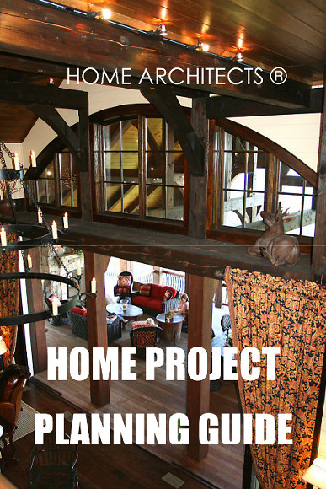

Home Project Planning Guide is a new mini-e-book written by the HOME ARCHITECTS ®. This 35-page electronic book provides a summary background and checklist of the things you might want to be doing to plan for your proposed new residential project, along with the information you could be gathering for your Architect.

Read the online feature story to find out more… (click the photo to see the article. If no photo appears above, click the link below or copy and paste it into your browser)

http://www.homearchitects.com/home-project-planning-guide

Passive Solar Home Design 101
Back to Index
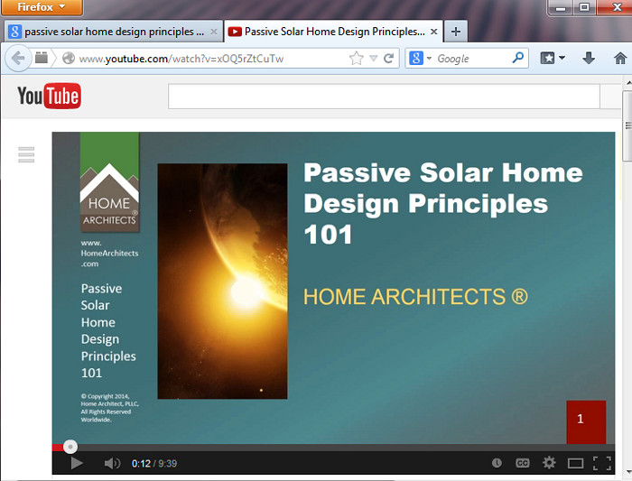

Passive Solar House Design Principles 101 is the title of a mini-course of instruction provided by HOME ARCHITECTS ®. Their Senior Staff Architect, Rand Soellner, ArCH, NCARB, LHI, M.A. Arch, recently taught this short course to a group of Middle School students in Ohio.

Read the article to learn more… (click the photo to see the article. If no photo appears above, click the link below or copy and paste it into your browser)

http://www.homearchitects.com/passive-solar-house-design-principles-101

Custom Residential Design
Back to Index

Custom residential design is best accomplished with an Architect designing the house. Why, you might ask? That is the subject of this article.
(click the photo to see the article. If no photo appears above, click the link below or copy and paste it into your browser)

http://www.homearchitects.com/custom-residential-design-2

Back to Index
End of this edition.

© Copyright 2014 Home Architect, PLLC, All Rights Reserved Worldwide
HOME ARCHITECTS ® 1 . 828 . 269 . 9046
Rand@HomeArchitects.com www.HomeArchitects.com

Anyone is hereby licensed & encouraged to forward this e-magazine to anyone else, making no changes.

