HOME ARCHITECTS ®
e-Magazine
Issue 27
July 2014

© Copyright 2014 Home Architect, PLLC, All Rights Reserved Worldwide
An online e-magazine affiliated with the HOME ARCHITECTS® website.
Editor: Rand Soellner, Architect, ArCH/NCARB/LHI.
HOME ARCHITECTS ® 1 . 828 . 269 . 9046
E-mail: Rand@HomeArchitects.com Website:www.HomeArchitects.com
This issue electronically first published on 7/1/2014, from the USA.

Hello Clients, prospective Clients & other people interested in home architecture.

You will find a brief summary about each online article, including a photo with a hotlink to that article. We usually will have about 3 to 6 online articles a month, contained within the latest e-magazine issue.

Click on the photos (you may or may not need to press your control key, then click the link) to be taken to those pages on your Internet browser. If you ever lose this e-magazine, just reopen the e- mail that contains it, or send us a request and we will promptly send you another. You may save it to your hard drive, if you wish.

If you think of an idea for a future story, let us know! We create custom articles to answer questions of our subscribers.

You are welcome to contact us if you have any questions about your project: 1-828-269-9046 or Rand@HomeArchitects.com . We look forward to being your Architect on your next project.

You are encouraged to forward this e-magazine along to other people. Thank you for your interest & patronage.

Technology comment: We are using state of the art 64-bit computers and 2013-2015 software. If you have older equipment and software, you may not be receiving everything properly. We apologize for any inconvenience.

Index for this issue

This is an electronic magazine. You can click the article title that most interests you and that will roll up on your screen. You can also click “Back to Index” just under the right side border of each article to return to this Index. Depending on your version of MS Word, you may have to press Cntrl + Click.

- Link to Basements are not free
- Link to Homestead Forever
- Link to Architect Lawyer Doctor Engineer CPA
- Link to Entrepreneur Architect Interview: ArCH

Basements are not free
Back to Index
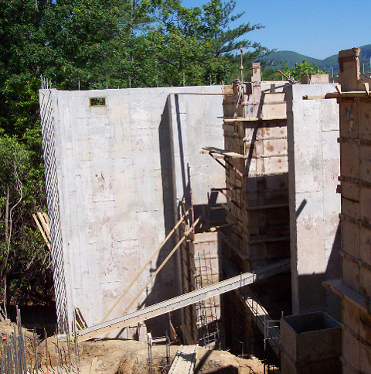

Nearly every client of the HOME ARCHITECTS ® waits to mention that they want a basement until after they have established the HSF (Heated Square footage) desired in the house. Then they typically and casually mention: “Oh, yeah, and a full basement”…
Read on to discover more… (click the photo to see the article. If no photo appears above, click the link below or copy and paste it into your browser)
http://www.homearchitects.com/basements-are-not-free

e-magazine continued below:

Homestead Forever
Back to Index

Homestead in this context, refers to people that want their new house project to become the hub of activity for their growing, extended family. Forever = for the rest of their lives. Their= the Owners of the project (which would be you).
Read the online feature story to find out more… (click the photo to see the article. If no photo appears above, click the link below or copy and paste it into your browser)
http://www.homearchitects.com/homestead-forever

Architect Lawyer Doctor Engineer
CPA
Back to Index

Architect Lawyer Doctor Engineer CPA (ALDEC): what do all of these have in common? Right: they are all professional occupations that are licensed by State governments.
Read the article to learn more… (click the photo to see the article. If no photo appears above, click the link below or copy and paste it into your browser).
http://www.homearchitects.com/architect-lawyer-doctor-engineer-cpa

Entrepreneur Architect Interview:
ArCH
Back to Index
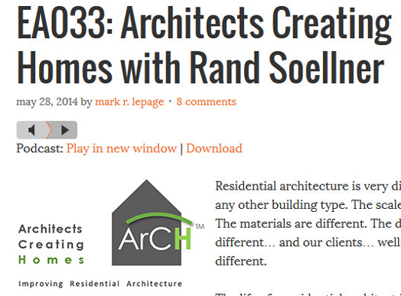

What you pay an Architect Entrepreneur Architect’s podcasts come off as being like the NPR (National Public Radio) of architecture. It feels and sounds a lot like the Prairie Home Companion of Garrison Keillor fame.
Read the article for more information. (click the photo to see the article. If no photo appears above, click the link below or copy and paste it into your browser).
http://www.homearchitects.com/entrepreneur-architect-interview-arch

Back to Index
End of this edition.

© Copyright 2014 Home Architect, PLLC, All Rights Reserved Worldwide
HOME ARCHITECTS ® 1 . 828 . 269 . 9046
Rand@HomeArchitects.com www.HomeArchitects.com

Anyone is hereby licensed & encouraged to forward this e-magazine to anyone else, making no changes.

