HOME ARCHITECTS ®
e-Magazine
Issue 30
Oct 2014

© Copyright 2014 Home Architect, PLLC, All Rights Reserved Worldwide
An online e-magazine affiliated with the HOME ARCHITECTS® website.
Editor: Rand Soellner, Architect, ArCH/NCARB/LHI.
HOME ARCHITECTS ® 1 . 828 . 269 . 9046
E-mail: Rand@HomeArchitects.com Website:www.HomeArchitects.com
This issue electronically first published on 10/4/2014, from the USA.

Hello Clients, prospective Clients & other people interested in home architecture.

You will find a brief summary about each online article, including a photo with a hotlink to that article. We usually will have about 3 to 6 online articles a month, contained within the latest e-magazine issue.

Click on the photos (you may or may not need to press your control key, then click the link), (or click on the text link near the end of each article summary) to be taken to those pages on your Internet browser. If you ever lose this e-magazine, just reopen the e- mail that contains it, or send us a request and we will promptly send you another. You may save it to your hard drive, if you wish.

If you think of an idea for a future story, let us know! We create custom articles to answer questions of our subscribers.

You are welcome to contact us if you have any questions about your project or would like us to become your Architect: 1-828-269-9046 or Rand@HomeArchitects.com . We look forward to being your Architect on your next project.

You are encouraged to forward this e-magazine to other people. Thank you for your interest & patronage.

Technology comment: We are using state of the art 64-bit computers and 2013-2015 software. If you have older equipment and software, you may not be receiving everything properly. We apologize for any inconvenience.

Index for this issue

This is an electronic magazine. You can click the article title that most interests you and that appear your screen. You can also click “Back to Index” just under the right side border of each article heading to return to this Index. Depending on your version of MS Word, you may have to press Cntrl + Click.

- Link to Optimizing Site Views
- Link to 720p vrs 1080p vrs 4k Video
- Link to What to Expect from your Architect
- Link to Books about Residential Architecture

Optimizing Site Views
Back to Index
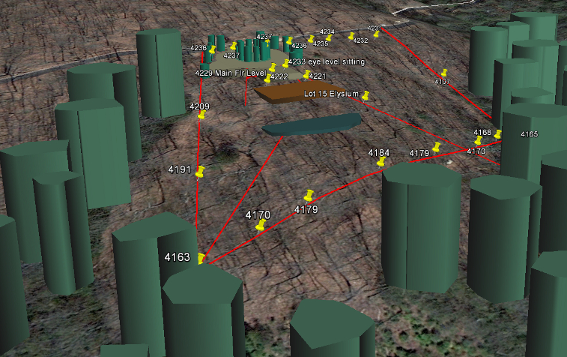

Optimizing Site Views is all about HOME ARCHITECTS ® analyzing the best location for your dream house on your dream land.
… (click the photo to see the article. If no photo appears above, click the link below or copy and paste it into your browser)
http://www.homearchitects.com/optimizing-site-views

e-magazine continued below:

720p vrs 1080p vrs 4k Video
Back to Index

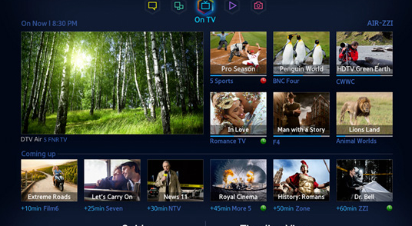

720p vrs 1080p vrs 4k video is about TVs and video technology. Every once in a while, there is a crossroads in technology that affects everything. This is one of those.
Read the online feature story to find out more… (click the photo to see the article. If no photo appears above, click the link below or copy and paste it into your browser)
http://www.homearchitects.com/720p-vrs-1080p-vrs-4k-video

What to Expect from your Architect
Back to Index
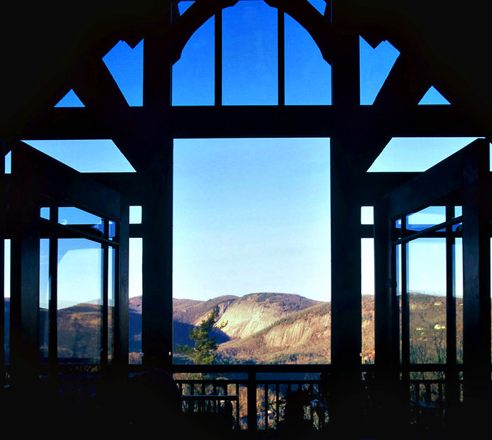

What to Expect from Your Architect: that’s a good subject. Most people hire an Architect only once: perhaps to design their dream house and have no experience and don’t know what to expect. This online article tells you exactly that.
Read the article to learn more… (click the photo to see the article. If no photo appears above, click the link below or copy and paste it into your browser).
http://www.homearchitects.com/what-to-expect-from-your-architect

Books about Residential Architecture
Back to Index

For books about residential architecture, you’ve come to the right place. HOME ARCHITECTS ® writes more books about residential architecture than any other Architect on the planet, to our knowledge.
Read the article to learn more… (click the photo to see the article. If no photo appears above, click the link below or copy and paste it into your browser).
http://www.homearchitects.com/books-about-residential-architecture

Back to Index
End of this edition.

© Copyright 2014 Home Architect, PLLC, All Rights Reserved Worldwide
HOME ARCHITECTS ® 1 . 828 . 269 . 9046
Rand@HomeArchitects.com www.HomeArchitects.com

Anyone is hereby licensed & encouraged to forward this e-magazine to anyone else, making no changes.

