HOME ARCHITECTS ®
e-Magazine
Issue 31
Nov 2014

© Copyright 2014 Home Architect, PLLC, All Rights Reserved Worldwide
An online e-magazine affiliated with the HOME ARCHITECTS® website.
Editor: Rand Soellner, Architect, ArCH/NCARB/LHI.
HOME ARCHITECTS ® 1 . 828 . 269 . 9046
E-mail: Rand@HomeArchitects.com Website: www.HomeArchitects.com
This issue electronically first published on 11/2/2014, from the USA.

Hello Clients, prospective Clients & other people interested in home architecture.

You will find a brief summary about each online article, including a photo with a hotlink to that article. We usually will have about 3 to 6 online articles a month, contained within the latest e-magazine issue.

Click on the photos (you may or may not need to press your control key, then click the link), (or click on the text link near the end of each article summary) to be taken to those pages on your Internet browser. If you ever lose this e-magazine, just reopen the e- mail that contains it, or send us a request and we will promptly send you another. You may save it to your hard drive, if you wish.

If you think of an idea for a future story, let us know! We create custom articles to answer questions of our subscribers.

You are welcome to contact us if you have any questions about your project or would like us to become your Architect: 1-828-269-9046 or Rand@HomeArchitects.com . We look forward to being your Architect on your next project.

You are encouraged to forward this e-magazine to other people. Thank you for your interest & patronage.

Technology comment: We are using state of the art 64-bit computers and 2013-2015 software. If you have older equipment and software, you may not be receiving everything properly. We apologize for any inconvenience.

Index for this issue

This is an electronic magazine. You can click the article title that most interests you and that appear your screen. You can also click “Back to Index” just under the right side border of each article heading to return to this Index. Depending on your version of MS Word, you may have to press Cntrl + Click.

- Link to Finding Land for your House
- Link to How Long Do We Have?
- Link to Psychology of Construction Cost Denial

Finding Land for your House
Back to Index
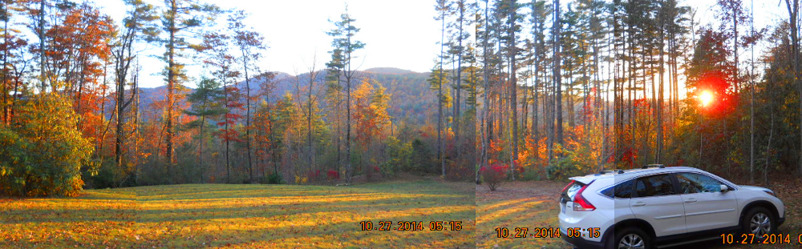

Finding Land for your House is about how an Architect and his Real Estate Broker wife went about finding the land for their forever house.

… (click the photo to see the article. If no photo appears above, click the link below or copy and paste it into your browser)
http://www.homearchitects.com/finding-land-for-your-house

e-magazine continued below:

How Long Do We Have?
Back to Index

How long do we have is about how much time each of us has left on this planet. And what you might want to do with the time you have.

Read the online feature story to find out more… (click the photo to see the article. If no photo appears above, click the link below or copy and paste it into your browser)
http://www.homearchitects.com/how-long-do-we-have

Psychology of Construction Cost
Denial
Back to Index

Psychology of Construction Cost Denial is about what we ALL go through when we start a custom house project. We all (every single one of us) firmly believes that we will get our new house project built for about 1/2 to 1/3 of what the actual final cost will end up being.

Read the article to learn more… (click the photo to see the article. If no photo appears above, click the link below or copy and paste it into your browser).
http://www.homearchitects.com/psychology-of-construction-cost-denial

Back to Index
End of this edition.

© Copyright 2014 Home Architect, PLLC, All Rights Reserved Worldwide
HOME ARCHITECTS ® 1 . 828 . 269 . 9046
Rand@HomeArchitects.com www.HomeArchitects.com

Anyone is hereby licensed & encouraged to forward this e-magazine to anyone else, making no changes.

