HOME ARCHITECTS ®
e-Magazine
Issue 33
Jan 2015

© Copyright 2015 Home Architect, PLLC, All Rights Reserved Worldwide
An online e-magazine affiliated with the HOME ARCHITECTS® website.
Editor: Rand Soellner, Architect, ArCH/NCARB/LHI.
HOME ARCHITECTS ® 1 . 828 . 269 . 9046
E-mail: Rand@HomeArchitects.com Website: www.HomeArchitects.com
This issue electronically first published on 1/1/2015, from the USA.

About this e-magazine

You are receiving this because you either subscribed, or downloaded an online book from HomeArchitects.com, with a free subscription.

Hello Clients, prospective Clients & other people interested in home architecture. WE DESIGN CUSTOM HOMES NATIONWIDE.

Below, you will find a brief summary about each online article, including a photo with a hotlink to that article. We usually will have about 3 to 6 online articles a month, contained within the latest e-magazine issue.

Click on the photos (you may or may not need to press your control key, then click the link), (or click on the text link near the end of each article summary) to be taken to those online articles on your Internet browser. If you ever lose this e-magazine, just reopen the e- mail that contains it, or send us a request and we will promptly send you another. You may save it to your hard drive, if you wish.

If you think of an idea for a future story, let us know! We create custom articles to answer questions of our subscribers.

You are welcome to contact us if you have any questions about your project or would like us to become your Architect: 1-828-269-9046 or Rand@HomeArchitects.com . We look forward to being your Architect on your next project.

You are encouraged to forward this e-magazine to other people. Thank you for your interest & patronage.

Technology: We are using state of the art 64-bit computers and 2013-2015 software. If you have older equipment and software, you may not be receiving everything properly. We apologize for any inconvenience.

Index for this issue

This is an electronic magazine. Click the article title that most interests you and that will appear your screen. You can also click “Back to Index” just under the right side border of each article heading to return to this Index. Depending on your version of MS Word, you may have to press Cntrl + Click.

- Link to Bank Loan Process
- Link to The BRIDGE: latest new space in house design
- Link to Alabama House Design
- Link to Educational Website about House Design

Bank Loan Process
Back to Index
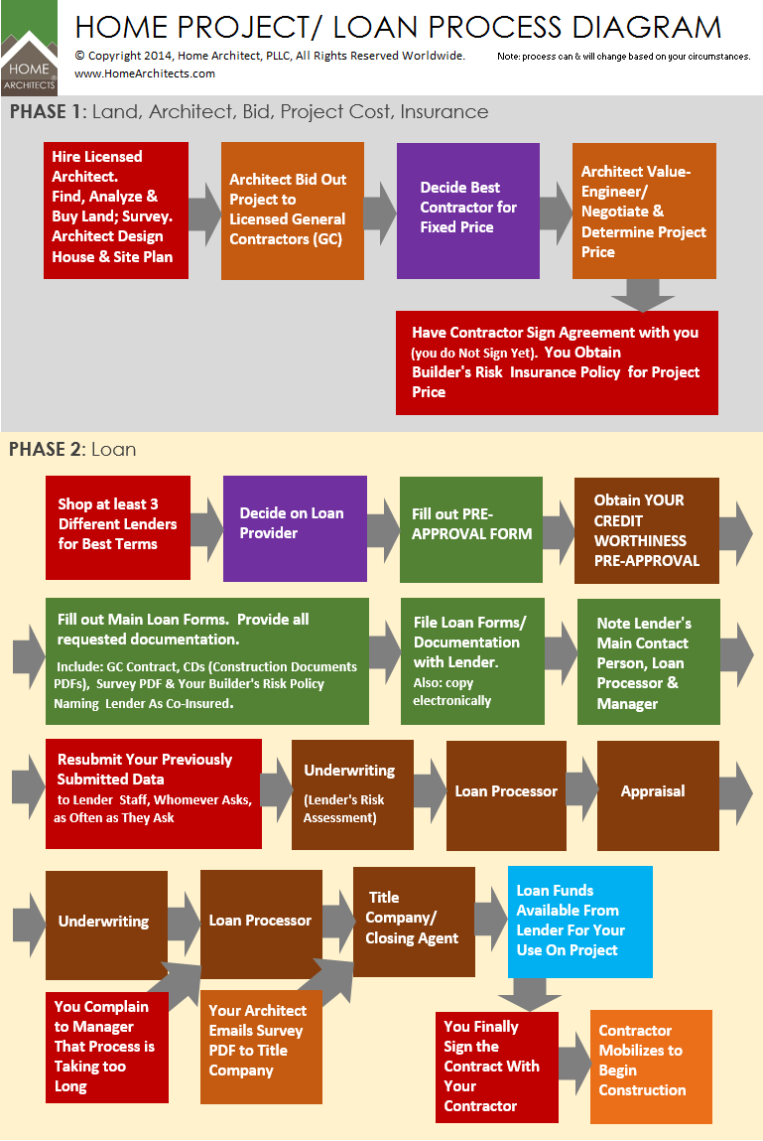

Bank Loan Process is about what people just like you go through when you want to obtain a loan to build your house project, written by a leading custom residential Architect with decades of experience.

… (click the photo to see the article. If no photo appears above, click the link below or copy and paste it into your browser)
http://www.homearchitects.com/bank-loan-process

e-magazine continued below:

The BRIDGE: latest new space in
house design
Back to Index

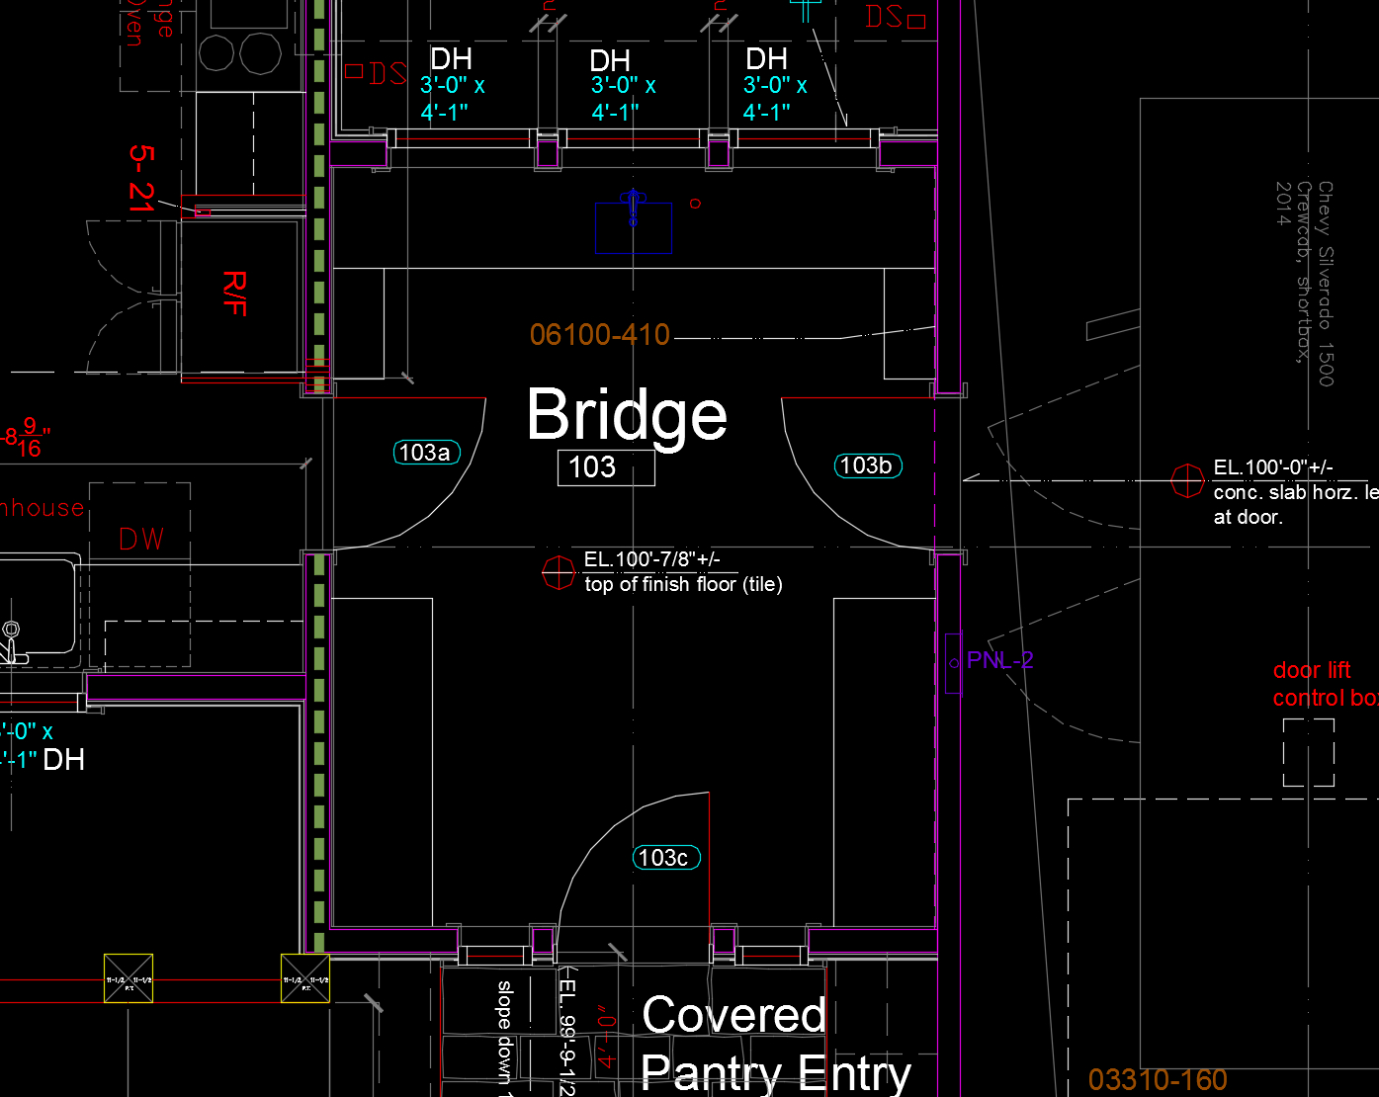

The BRIDGE is the latest design sensation from HOME ARCHITECTS ®. The Bridge is a space located between the Garage and the Kitchen.

Read the online feature story to find out more… (click the photo to see the article. If no photo appears above, click the link below or copy and paste it into your browser)
http://www.homearchitects.com/the-bridge-latest-new-space-in-house-design

Alabama House Design
Back to Index
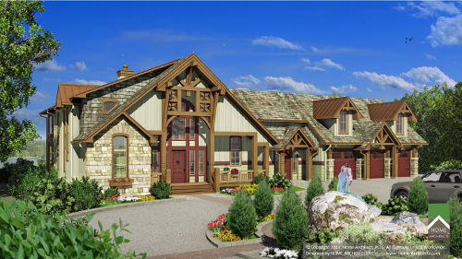

Alabama House Design is about a new, exciting post and beam project underway in the Cherokee, Alabama area, designed by HOME ARCHITECTS ®.

Read the article to learn more… (click the photo to see the article. If no photo appears above, click the link below or copy and paste it into your browser).
http://www.homearchitects.com/alabama-house-design

Educational Website about
House Design
Back to Index

Educational Website about House Design: is about this website: www.HomeArchitects.com . What may have begun as a simple website a dozen years ago has morphed into the leading website in the USA about INFORMATION & EDUCATION for residential architecture and construction.

Read the article to learn more… (click the photo to see the article. If no photo appears above, click the link below or copy and paste it into your browser).
http://www.homearchitects.com/educational-website-about-house-design

Back to Index
End of this edition.

© Copyright 2015 Home Architect, PLLC, All Rights Reserved Worldwide
HOME ARCHITECTS ® 1 . 828 . 269 . 9046
Rand@HomeArchitects.com www.HomeArchitects.com

Anyone is hereby licensed & encouraged to forward this e-magazine to anyone else, making no changes.

