HOME
ARCHITECTS ®
MAGAZINE

© Copyright 2012 Home Architect, PLLC, All Rights Reserved Worldwide
An online e-magazine affiliated with the HOME ARCHITECTS® website.
Editor: Rand Soellner, AIA/NCARB/LHI.
HOME ARCHITECTS ®
1 . 828 . 269 . 9046
E-mail: Rand@HomeArchitects.com
Website: www.HomeArchitects.com
This issue electronically first published on 9/6/2012, from the United States of America.

Issue 5, September 2012

Hello Clients, prospective Clients & other people interested in home architecture.

You will find a brief summary about each online article, followed by a hotlink to that article. We usually will have about 3 to 6 online articles a month, contained within the latest e-magazine issue.

Just click on the links (you may have to press your control key, then click the link) to be taken to those pages on your Internet browser. If you ever lose this e-magazine, just reopen the e-mail that contains it, or send us a request and we will promptly send you another. You may save it to your hard drive, if you wish.

You are welcome to contact us if you have any questions (about your project or our articles): 1-828-269-9046 or Rand@HomeArchitects.com .
We hope to be your architect on your next project.

You are encouraged to forward this e-magazine along to other people.
Thank you for your interest.

A Very Good Reason to Hire An Architect

There are unlicensed crooks out there in the world, scamming unsuspecting people that want a home built or renovated. These unlicensed “builders” can take you for tens of thousands if not hundreds of thousands of your hard-earned dollars. Don’t let this happen to you. Your home architect will perform research to detect these scammers from a mile away and make sure you have decent, quality general contractors from which to choose. If the HOME ARCHITECTS ® are designing your house, and you have them managing your bidding and/or construction, they will find out who your potential builders really are. Read the article to find out how…

Click below to see the article:
http://www.homearchitects.com/a-very-good-reason-to-hire-an-architect

How Different Styles Impact Budget

Our firm: HOME ARCHITECTS ® will write custom articles to satisfy the information needs for some of our clients and potential clients. One such client requested this article. It examines how the style and amount of detail and material choices you make affect your budget. See the article to learn more…

Click below to see the article:
http://www.homearchitects.com/how-different-styles-impact-budget

What You Should Not Scrimp on in Your Project

Marsha has requested that we write a custom article to answer her question: What Should I Not Scrimp on in My Project? So, we created this article for her and those of you that might have similar questions. Read the article to discover what these items are…

Click below to see the article:
http://www.homearchitects.com/what-you-should-not-scrimp-on-in-your-project

Kickout Flashing
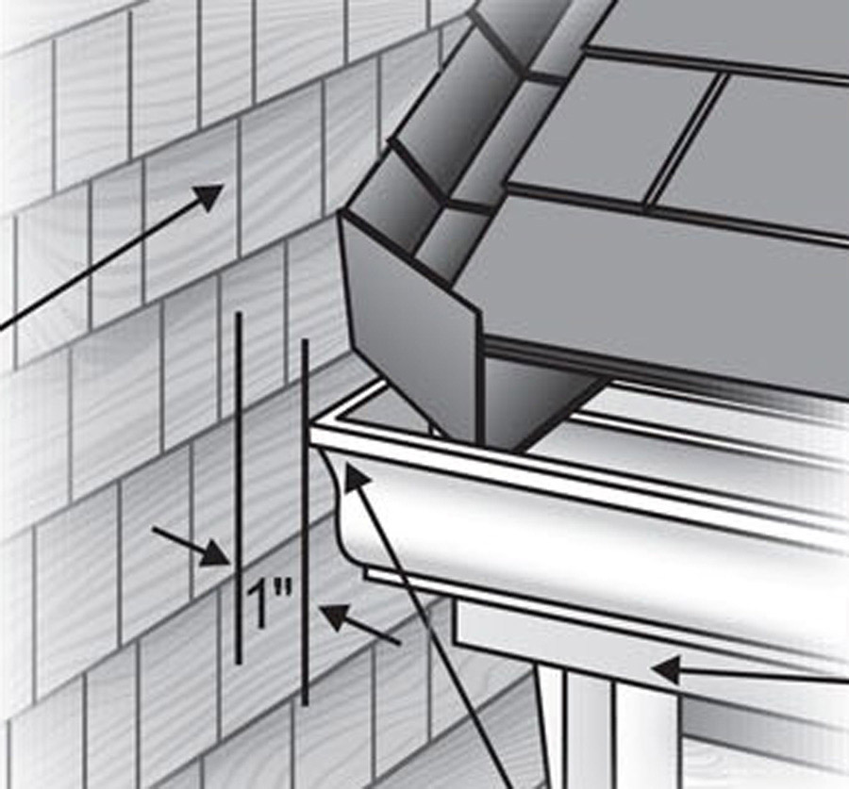

This is a technical article that just might save you tens of thousands of dollars in repairs, years after your home is built. How? Read the article to understand how quality residential architects provide this sort of detail to keep your new house dry…

Click below to see the article:
http://www.homearchitects.com/kick-out-flashing

End of this edition.

© Copyright 2012 Home Architect, PLLC, All Rights Reserved Worldwide
HOME ARCHITECTS ®
1 . 828 . 269 . 9046
Rand@HomeArchitects.com
www.HomeArchitects.com

Anyone is hereby licensed to forward this e-magazine to anyone else, making no changes.

