HOME
ARCHITECTS ®
MAGAZINE

© Copyright 2012 Home Architect, PLLC, All Rights Reserved Worldwide
An online e-magazine affiliated with the HOME ARCHITECTS® website.
Editor: Rand Soellner, AIA/NCARB/LHI.
HOME ARCHITECTS ®
1 . 828 . 269 . 9046
E-mail: Rand@HomeArchitects.com
Website: www.HomeArchitects.com
This issue electronically first published on 10/3/2012, from the United States of America.

Issue 6, October 2012

Hello Clients, prospective Clients & other people interested in home architecture.

You will find a brief summary about each online article, followed by a hotlink to that article. We usually will have about 3 to 6 online articles a month, contained within the latest e-magazine issue.

Just click on the links (you may have to press your control key, then click the link) to be taken to those pages on your Internet browser. If you ever lose this e-magazine, just reopen the e-mail that contains it, or send us a request and we will promptly send you another. You may save it to your hard drive, if you wish.

If you ever think of an idea for a future story, let us know! We routinely create custom articles to answer the questions of our subscribers.

You are welcome to contact us if you have any questions (about your project or our articles): 1-828-269-9046 or Rand@HomeArchitects.com .
We hope to be your architect on your next project.

You are encouraged to forward this e-magazine along to other people.
Thank you for your interest.

Spectacular House with 40 Mile Views

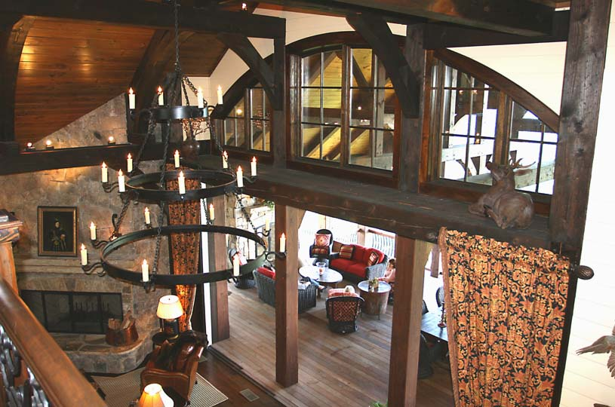

Rand Soellner, AIA and his wife, Merry Soellner, who happens to be one of the leading real estate brokers in this region, recently attended an open house of one of his designs. This house was built on the highest site available in the Highlands Cove subdivision, between Highlands and Cashiers, North Carolina, in the Blue Ridge Mountains. This is an amazing residence with many features that wowed that attendees. Read the article to discover this fabulous house…

Click below to see the article:
http://www.homearchitects.com/spectacular-house-with-40-mile-views

Freezing Weather: Your House’s Hose Bibbs

There are a few things you should do every year, as temperatures begin to drop. As fall arrives, watch out for colder temperatures at night. It was recently about 37*F around here, and that was near the end of September. Freezing temperatures can damage your house if you have not prepared. Read the article to find out what to do…

Click below to see the article:
http://www.homearchitects.com/freezing-weather-your-houses-hose-bibbs

Septic Grinder Pumps & Force Mains

Some people have asked why we only show pretty pictures of beautiful houses, and if we can also get into the nitty-gritty aspects of housing construction. Well, okay this one’s for you folks. This is one of those unglamorous hard core articles about the kind of thing nobody wants to think about until there is a problem. Septic grinder pumps and force mains for sewers are becoming more common as lot sizes shrink, meaning there is not always room for a septic drain field, so a centralized sewer processing facility may be necessary for certain communities, remote from the neighborhoods. See the article to learn more…

Click below to see the article:
http://www.homearchitects.com/septic-grinder-pumps-force-mains

Good Design Adds Value to Your House
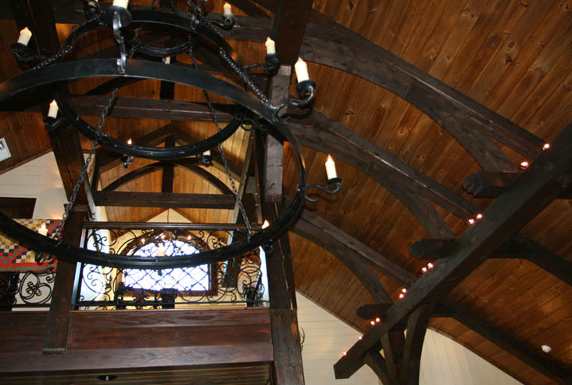

Professional Builder magazine had an interesting article in its July, 2012 issue: “Is Design More Important Than Price or Location?” In the final analysis, it turned out that DESIGN IS EQUALLY AS IMPORTANT AS LOCATION for the top 2 main determinants of housing appeal, even more important than price. Read more to discover why you should consider having your new house project incorporate good design as developed by one of the leading home architects.…

Click below to see the article:
http://www.homearchitects.com/good-design-adds-value-to-your-house

Ocean Home Magazine Article Featuring Rand Soellner

OceanHome

Rand Soellner, AIA was featured in a new article, dated September 4, 2012 in Ocean Home Magazine. Reporter and writer, Alexandria Churchill interviewed Rand and included his views about Green and how everything in our ecosystem is connected…

Click below to see the article:
http://www.homearchitects.com/ocean-home-magazine-article-featuring-rand-soellner

End of this edition.

© Copyright 2012 Home Architect, PLLC, All Rights Reserved Worldwide
HOME ARCHITECTS ®
1 . 828 . 269 . 9046
Rand@HomeArchitects.com
www.HomeArchitects.com

Anyone is hereby licensed to forward this e-magazine to anyone else, making no changes.

